The OSSCA Quarterly
May

2018

ATTRACTIONS

Comment from the President, John Johnson
Comment from the Executive Director and Editor of The Quarterly, Gary Avedikian
Comment from College Coaches
John Bluem – The Ohio State University DI

Comment from Fellow High School Coaches
Coach Zorro – Sword High School - Favorite practice

Comment from Director of Referees, Don Muenz
Rules Changes

Comment from the Sport Psychologist, Dr. Jen Carter
Response to Question of the Month from a Member
Brent Walker – Glen Oak High School

A Special Editorial from Soccer America About High School Soccer
Mike Woitalla

From the President
John Johnson
OSSCA Members,
Greetings from the OSSCA. Now that the school year is coming to a close there a few items that we would like to remind you of. All coaches need to start to input their 2018 schedule on the OSSCA website (OSSCA.org). If you forget your login or password you can send me an email and I will send that information to you. The online rules meeting should be up and running in July and Jerry Snodgrass will send your AD information letting you know the time frame in which the rules meeting must be completed. In a few weeks each district president will receive dues information and they will email you with that information. You can also check the state website in a few weeks to find the dues information on the home page. There are not many changes to the dues information other than some deadlines have been revised so please make sure you meet the deadlines. If you have questions regarding your dues you can contact your district president or the contact listed on the information sheet.
In April, I attended a meeting at the OHSAA for all association president’s. They shared some very interesting information that I would like to share with you.

- The OHSAA has presented a new transfer rule to the Board of Control. There is a major change in this transfer rule. Previously, if a student transferred they had to sit out the first 50% of the maximum allowable games which is 8 games. The new proposal states that if a player does not meet certain exceptions then that student will be permitted to play in the first 50% of the maximum allowable games but then must sit out all remaining games and all post season tournament games. This is a major change if the board passes it.

- There are divisional changes again this year due to competitive balance. 40 schools on the boy’s side will be impacted and have some type of movement. 24 schools will be moved up a division and 16 will be moved down. On the girl’s side 35 schools will be impacted and have some type of movement. 20 schools will be moved up and 15 will move down. You can go the OHSAA website at OHSAA.org.

- The OHSAA shared ejections numbers from the 2017 season. On the boy’s side ejections increased by 4 and a total of 238 individuals were ejected from a game. 217 players were ejected, which is down by 3 from 2016. 21 coaches were ejected which is up by 7 from 2016. We have been seeing a decline in overall ejections until the 2017 season. On the girl’s side ejections rose by 7. 58 players were ejected compared to 50 in 2017. 3 coaches were ejected which declined by 1 from 2016. As coaches we still need to reinforce sportsmanship and work hard to decrease our numbers in 2018.

- The OSSCA presented a rule change to the National Federation of State High School Associations (NFHS). The NFHS is the governing body that creates all playing rules for high school sports. Don Muenz, OHSAA State Rules Interpreter, helped us write the rule proposal in the language required by the NFHS. The United Soccer Coaches also sent a letter of support for our proposal and other state soccer associations also endorsed this proposal. The proposal was to allow the home team to wear their school colors at home matches and to wear all white for away matches. This is simply a reversal of how things have been the past several years. The reason for the proposal came from coaches in our state that requested they be allowed to wear their school colors at home since some schools do not have white as their official school color. The NFHS approved this rule change and it will go into effect for the 2018 season.

- I was given an update on the official tournament ball that will used starting at the regional level. The update is they have not signed a contract yet. The OSSCA is asked for input the OHSAA makes the final decision and they have not released that information yet. They did reinforce that all game balls used during the season must have the official NFHS logo on it.

- One last item is simple reminder that the OHSAA is again promoting Friday Night Futbol on August 17. If you take part in the event Jerry Snodgrass would like you to tweet out pictures or send them to him and he will send them out.

Each year the OSSCA elects some new executive officers and this year the following candidates will be on an online ballot during the month of May on the OSSCA website (OSSCA.org). Each office has one candidate but if you are interested in running for a position you can contact me and we will put you on the ballot. The only requirement to run for office is that you must currently be a member of the OSSCA.
- Secretary – the OSSCA secretary simply keeps the minutes of each board meeting. They prepare the minutes after the meeting and send them to the president. Once the minutes are approved at the next board meeting they are then sent to the OSSCA webmaster to be placed on website. This position has voting rights on all board issues. Bill Mees from Indian Hill is currently our secretary and will be running for another term.
- Vice-President of Honors – the OSSCA VP of Honors coordinates the All-State voting meeting. They prepare the forms during the summer and send them out to the district presidents and webmaster. At the All-State meeting they coordinate the tallying of the ballots for All-State. All special awards are organized by the VP of Honors along with coordination with the United Soccer Coaches regarding All-Region and All-American Honors. This position has voting rights on all board issues. George Hunter is currently the VP of Honors and is seeking another term, but this term will be George’s last term. Individuals can run for this office or they can request to be George’s assistant for the term to gain a better understanding of the position with the hope they will run for the office once George’s term expires. This is a very important position and one that requires an organized individual that has basic computer skills.
- Vice-President of Education: the OSSCA VP of Education is a relatively new position that simply provides educational opportunities for our members. They will help with OSSCA Quarterly Journal by adding some educational articles or seek out individuals to provide articles. Our desire is to use technology to provide coaches a site to go to for coaching activities. They can create a Twitter account for coaches to follow, a blog or forum for coaches to provide input on a variety of activities. This position has voting rights on all board issues. Bryan Daniel from Indian Hill High School has expressed interest in running for the position.

I hope you have a wonderful summer and if you ever have any questions please email me at johncjohnson1965@gmail.com or call me at 330-329-4611.

Yours in Soccer,
John Johnson
OSSCA, President
Wadsworth High School
From the Executive Director of OSSCA
Gary Avedikian

Support for High School Soccer

There is, finally, a growing national realization that the role of high school soccer is very significant in the future of youth soccer development. As we all know, it is one of the few places where the players play in a U19 environment. Being with older players and playing in a season that actually ends and having all their peers know how they did last time out is a rare experience. Learning that only one team will end the season with a win is a hard but very important lesson for players. It is something they will only experience in high school soccer.
In the near future, I believe high school soccer will get more support from the college game because increasingly they are realizing that the growth of quality players and the number of fans at the high school level will later translate into the kind of support that college basketball and football receive.
It will take quite a while for the professionals to get it because they are still caught up in the cycle of imitating European professional behavior. That's fine. There is a place for it, but their fans, like pro football fans are going to come from the former high school and college players.
When Jurgen Klinsmann was in Columbus he spoke to a small group of coaches prior to the MNT game. He made a comment which seemed to sail over many heads in the room who didn’t appreciate the meaning. He said that the professional game can’t create the same passion here as it does in Europe because Americans relate most strongly to their high schools and colleges sports team outcomes.
I believe some with power in soccer maybe finally getting it.
FYI: Membership Deadlines
Akron August 15th
Central September 1st
Cleveland August 15th
East September 1st
Miami Valley August 13th
North Central August 25th
Northwest August 11th
Southeast September 1st
Southwest August 15th
Youngstown August 13th
Districts using Blue Sombrero:
Cleveland
North Central
Northwest
Youngstown
Akron

If more districts are added to the Blue Sombrero list, your districts will make it clear in time and with your directions.

John Bluem – Recently Retired Men’s Soccer Coach OSU

Creating Scoring Chances

It is easy for players with the ball to come up with options for their next move. However, when we ask players without the ball –

What are your options?...Who tells you what to do next?...How can you help your teammate with the ball?...When do you look to help the player with the ball?...Where do I run to be effective in the attacking third?

-we probably find a lot of blank stares coming our way. This session will help to clarify the thought patterns that should be present in the players’ minds when their team is trying to Create Scoring Chances.

Warm-up
- Organization: Pairs w/one ball between two players
  - Player w/ball dribbles – Partner checks–Play to feet–turn & go
  - Player w/ball dribbles – Partner checks (one step) and runs to space – Play to space
  - Player w/ball dribbles – Partner checks/receives/& takes big first touch to split two players at ¾ speed
  - Player w/ball dribbles – Partner checks–Double Pass-Repeat
  - Player w/ball dribbles – Partner checks/receives/turns/dribbles–Overlap

Session
- 1 v 1 (+1) To Target
  - 1 v 1 In Grid 15 x 20 yds w/Full Size Goals
  - Play to Target – Follow
  - Play to Depth – One/Two Touch Shot

- 1 v 1 (+1) To Target
  - 1 v 1 In Grid 15 x 20 yds w/Full Size Goals GK
  - Play Back To Support From Behind
  - Play Target – Follow
  - One/Two Touch Shot T

- 1 v 1 to 1 v 1 (Marked Target)
  - 1 v 1 In Grid 15 x 20 yds w/Full Size Goals XXX o
  - Find Target (Opposite) or Support From Behind OOO X
  - Go to Support Target – Play 2 v 1 To Get Shot
T
- 2 v 2 To 2 v 1 (Two Attackers & One Defender)
  - 2 v 1 In Grid 15 x 20 yds w/Full Size Goals
  - Must Play Back To Support From Behind
  - Support Plays Open Player or Target GK
  - Both Players Find Support Angles–Behind/Advance

- Build Exercise In Numbers and Choices

- Game.
- 8 vs 8

Coaching Points
- Think Ahead
- Speed of Play
- Showing for the Ball (Open vs Back to Goal)
- Getting in Advance of the Ball
- Passing To Space vs Passing To Feet
- Creating Passing Angles
- Dragging Defenders
- Depth of Support
- Reading the Pressure on the Ball
- Running to Space vs to Support

From Ohio High School Coaches
Coach Zorro – Sword High School - Favorite practice
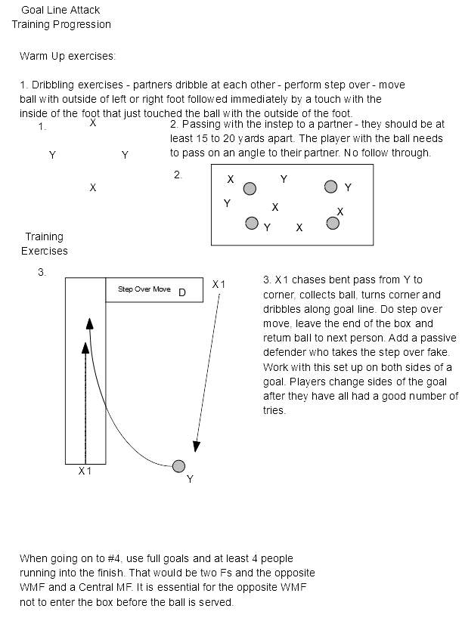
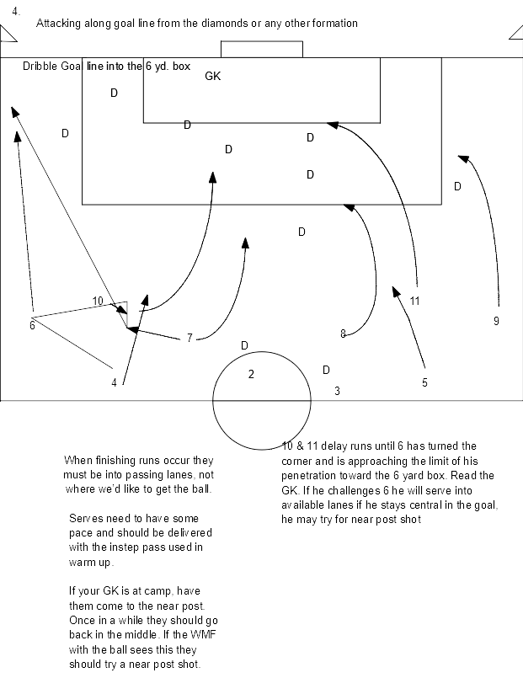

From the Director of Referees for the OHSAA
Don Muenz

2018-2019 NFHS Rules Changes and Points of Emphasis
Good day, Coach.
Following is a summary of major rules changes for the upcoming season along with Comments on the Rules and, (hopefully) helpful examples.
NF 4.1.1(a) and –(b) Home and Visitors’ Jerseys/Socks
Beginning this fall season, the home team wears dark jerseys and socks, reversing the practice of the past five years. Dust off those school colors and wear them proudly at each and every home match!
Dark is defined as any color which contrasts with white.
Visitors now wear solid white jerseys and solid white socks.
The color of home or visitors’ shorts is not specified in the rules, so wear your color of choice.
Home socks must be of a single, dominant, dark color.
Visitors’ socks must be solid white.
Visitors’ and home socks may have a manufacturer’s logo/trademark on each side of each sock.
Remember, if tape, stays or straps are worn over the sock, the tape, stay or strap must be of a similar color to that part of the sock to which it is applied or which it covers.
NF 4.1.1(d) and –(e) Visible Undergarments
Any visible apparel worn under either the jersey or shorts must be of similar length on the player who wears it and of a like, solid color for all who wear that apparel on the same team.
Example 1: A1, of the visiting team, wears a full-length white sleeve on her left arm and a very short, but still visible, white sleeve on her right arm. Illegal. On an individual player, the sleeves (arm or leg) must be of a similar length.
Example 2: Three players on Team B, the visitors, wear solid purple leg sleeves, while the remaining nineteen rostered players do not wear visible leg sleeves. Legal. Not every player on Team B must wear leg sleeves. All who wear leg sleeves must wear a like, solid color. On an individual player, each leg sleeve worn must be of similar length.
NF 4.2.10 [NEW] Medical/Cosmetic or Religious Head Coverings/Wraps
For the medical/cosmetic head covering/wrap: It must be required by a licensed physician. That physician’s statement must be sent with a picture of the covering/wrap to Director of Sport Management Jerry Snodgrass, for approval. The covering/wrap cannot be abrasive, hard or dangerous to any other player. The covering/wrap must be attached in such a way that it is highly unlikely to come off during play. Keep that approval in your match bag to show to the referee.
For the religious head covering/wrap: Along with a picture of the device on the player, you must send documented evidence that a participant may not expose the uncovered head. The covering/wrap cannot be abrasive, hard or dangerous to any other player. The covering/wrap must be attached in such a way that it is highly unlikely to come off during play. Keep that approval in your match bag to show to the referee.
NF 8.1.2 Kickoffs
The player taking the kickoff (and only that player) may step into his/her attacking half to execute the kickoff.
NF 11.1.4 Spot of Restart for Offside
The indirect free kick restart is now taken from the point where the foul of offside was completed, i.e., where the offside position player interfered with play, interfered with an opponent or gained an advantage by being in the offside position. The spot of the indirect free kick restart could be within the offending team’s defensive half of the field.
NF 12.8.1(f)(15) [NEW] Denial of Obvious Goal-Scoring Opportunity Where Penalty Kick Is Awarded
Where a defender commits a direct free kick offense against an opponent that denies an obvious goal-scoring opportunity and results in the award of a penalty kick, the offender will be cautioned if the offense resulted from an attempt to play the ball.
A red card would still be issued for denying an obvious goal-scoring opportunity within the penalty area if:
the offense was an indirect free kick foul;
the offense itself was violent conduct or serious foul play, NF 12.8.2(a) or 12.8.2(d)(1), respectively, or
the offense was holding, pushing, pulling or deliberate handling, which are not considered attempts to play the ball, new NF 12.8.2(d)(4), or otherwise not an attempt to play the ball.
NF 12.8.2(d)(3); -(d)(4) [NEW] Serious Foul Play; Denial of Obvious Goal-Scoring Opportunity
A player, coach or bench personnel may be disqualified (red card) for committing serious foul play:
(d) committing serious foul play:
(3) a player commits a foul, outside the penalty area, attempting to deny an obvious goal-scoring opportunity, and the goal is not scored. [Note: this can be a direct or indirect free kick foul.]
(4) a player commits a foul, inside the penalty area, while not attempting to play the ball, and the goal is not scored. [Note: Again, a direct or indirect free kick foul.]
NF 13.2.1(j) [NEW] Leaving/Entering Field Without Permission; Direct Free Kick for Interference With Play or Match Official
Direct free kicks are awarded and taken from the point of the infraction (Except as in 13.1.3 and 14.1.1):
(j) if a player, coach or bench personnel enters or leaves the field of play without permission of an official and interferes with play or an official (12.8.1);
NF 13.2.3 Entering/Leaving Field of Play Without Permission; No Interference With Play or a Match Official
Art. 3 The following indirect free kicks are taken from where the ball was when the referee stopped play: (Subject to restrictions in 13.1.3 and 13.1.4.)
a. If a player, coach or bench personnel enters or leaves the field of play without permission of an official and does not interfere with play or an official (12.8.1);
Example 1: A coach or bench personnel enters the field without permission and touches the ball with his hands to prevent a promising attack. If the interference occurred within the penalty area, a penalty kick would be awarded. If the interference occurred outside of the penalty area, a direct free kick would be awarded. NF 13.2.1(j)
Example 2: With the ball in play, bench personnel for Team A enters the field without permission but does not interfere with play. The referee chooses to stop play for this misconduct. The restart is an indirect free kick to Team B from the position of the ball when the referee stopped play. NF 13.2.3
Example 3: Player A1 leaves the field, across the touchline, in order to offer dissent to an assistant referee, who is positioned off of the field, preventing the assistant referee from following the ball, which is still in play. The interference did not occur within the team and coaching area. The restart is a direct free kick for Team B on the touchline, nearest the point of interference. NF 13.2.1(j)
NF 4.2.4 Religious Medals Worn by Players
A religious medal or other religious item must be taped to the body.
2018 Points of Emphasis #1 Denying an Obvious Goal-scoring Opportunity and What Constitutes an Obvious Goal-scoring Opportunity
“The penalty associated with a player who denies an obvious goal-scoring opportunity has been amended. In an effort to make the penalty better fit the infraction, now when a player commits an offense against an opponent within their own penalty area which denies an obvious goal-scoring opportunity and the referee awards a penalty kick, the offender is cautioned if the offense was an attempt to play the ball. Formerly, this player was disqualified and a penalty kick was awarded. In circumstances where there was no attempt to play the ball, the player is still disqualified.”
“In evaluating whether there has been an obvious goal-scoring opportunity, officials are encouraged to consider the following:
Distance between the offense and the goal (the offense must be near the goal)
General direction of play (the attacking players are generally headed toward the goal)
Likelihood of keeping or gaining control of the ball (the player must have or be able to get control of the ball in order to score)
Location and number of defenders (not more than one defender between the attacking player and the goal, not counting the player that committed the foul and the defenders must be able to challenge the attacking player)
If any of the above considerations are missing, it is not an obvious goal-scoring opportunity.”
Example 1: A1 attacks from just inside of her attacking penalty area, with the goalkeeper on the goal line between the posts. Twenty yards to her left is defender B3, who is closer to the goal line than A1. This is an obvious goal-scoring opportunity, though there are two defenders closer to the goal than A1, as B3 is unable to challenge A1, because she is too far away.
Example 2: B10 is one-on-one with the defending goalkeeper, two yards inside of the penalty mark. The goalkeeper comes out and B10 pushes the ball diagonally to the left. Simultaneously, the goalkeeper reaches up and trips B10, as B10 tries to jump over the goalkeeper and collect the ball, which is three yards away. This would still be an obvious goal-scoring opportunity, as the general direction of A10’s play is toward the goal.
Example 3: D5, near the halfway line in her own defensive half of the field, kicks the ball 25 yards into her attacking half, as the sole remaining defender, the goalkeeper for Team E, rushes out of her defensive penalty area to contest the ball. This is not an obvious goal-scoring opportunity, as there is no likelihood that D5 will regain possession of the ball.
2018 Points of Emphasis #2 Excessive Player Substitution “Concern has been expressed in situations where teams make excessive substitutions toward the end of a game in an effort to waste time. According to Rule 3.6, a referee has the discretion to stop the clock during the substitution so that this time is not lost. Further, the referee may consider the unsporting conduct and a caution may be issued to the coach of the offending team.”
2018 Points of Emphasis #3 Referee Mechanics for Indirect Free Kicks “For an indirect free kick, the referee must raise one arm vertically and maintain that position until the ball is touched by a second player. It is critical players know what type of free kick is occurring so the team taking the kick can properly execute the kick and the team defending know whether a goal may be scored directly from the kick. For indirect free kicks, if the ball enters the goal directly from the kick, the restart is a goal kick.”
Example 1: The referee awards an indirect free kick to Team A, twenty yards outside of their attacking penalty area, but fails to give the indirect free kick signal. A2 kicks the ball directly into the goal. The referee gives a goal kick to Team B. This is correct. There is no “do-over” as FIFA allows, even for this referee error.
There you have it. Have a great season.

From the Sports Psychologist for the OHSAA
Dr. Jen Carter - Director of OSU Sport Psychology

From Sport Psychology Newsletter; March 2000
Energy Management
Dr. Jen Carter - Director of OSU Sport Psychology

“I was so nervous that I was sick to my stomach, and I played horribly.”

“I felt flat. I couldn’t get psyched up, and my performance suffered.”

Have you heard athletes make such comments? A common struggle for athletes is to manage their energy level so that they perform at their best. Many athletes feel too nervous or tense prior to competing. Fewer athletes feel too low or flat prior to competing.

Energy and Performance

What is the relationship between energy level and performance? Yerkes and Sodson found an “Inverted ‘U’” relationship, in which a moderate level of anxiety brings about the best performance. If anxiety is too high or too low, then performance will suffer.

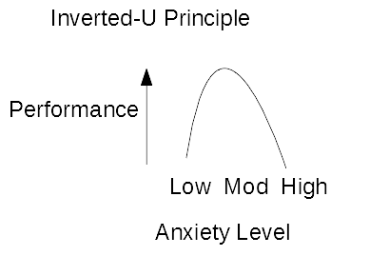
More recent research has suggested that the relationship between energy/anxiety and sport performance varies by individual and by sport. For example, football players may need higher energy levels than golfers. Karen may run faster when she is relaxed and laughing, whereas Bill may play defense better when he is “keyed up”.

How do you determine your optimal energy level? Imagine your best performances and assess your energy level prior to those performances. Or, keep a journal to track your energy level and how it affected performance.

Energy Management

It is helpful to know your optimal energy level on a scale of 1-10, with 1=very low energy and 10=very high energy. If your energy is too high or too low, engage these strategies:

To decrease your energy level:
- Take deep breaths and relax.
- Focus on what you can control (Technique, etc.)
- Challenge negative self-talk. Repeat cue words (“Clam”).
To increase your energy level:
- Get moving (jump up and down, shake out limbs).
- Use self-motivating self-talk.
- Listen to music.

From A Member: Questions of the Month

Gary,
Why has the psychological aspects of players become an integral part of coaching?
Brent Walker
Glenn Oak HS

Editor Answers:

Brent, my opinion on this matter has formed over a 67+ years as a player, high school and Division I college coach and club coaching and managing experiences.

Over those years the average coach wasn’t exposed to much, if any, teaching on the psychology of sport. Most of us probably modeled our treatment of players based on the coach we felt most close to for all kinds of reasons. Most likely, most of us would have had a hard time defining what it was about that, or those, coach(s) that were so significant to us.

When I look back at my years as a high school coach, I can see where I needed more training on the subject and where my players were teaching me by reflection. There were years when needing to be able to generate self confidence in a team would have been very important to their success on the field and at those times, sports psychology training would have made all the difference and other years where I had to tone down the confidence factor.

Also, since the 1970’s & 80’s, there has been a growing concern about just how mentally tough the later generations are. I have had very good high school and very good college coaches tell me that that the players over the last 20-30 years aren’t tough enough mentally to take individual responsibility for the outcome of a game. They say they hide in a group.

If this is true, then there is the answer to your question, Brent.

Brent, I also sought the input from the Editor of the Soccer Journal. I know he has more educated ideas about your question and can fill in the spaces I can’t.

Dr. Jay Martin’s Thoughts on the Subject:

In my opinion, there are many reasons. But the most important is that it is ignored by most coaches. Or
they have no idea how it works. The Mental has always been one of the “Four Pillars”. But, it is the least understood of them all.
Our coaching cycle is not good. Most people go into coaching because they had some success in the sport. If
they had a good coach, they have a chance to be a good coach…a chance. If not - which is more likely - they have no chance!! Since most coaches of past generations knew little about the Mental it is not passed on. And many coaches do not work hard at staying current(i.e. the advances in then psychological aspect of sport) in the art of coaching. Most young coaches know it all, have all the answers.

I believe that as you climb the athletic pyramid (my term) they difference between success and failure is
the mental. As athletes go from HS to college to pros, the Physical and Technical are very similar. The difference???
The Mental!!
I could respond to this all day. We have been successful in both soccer and lacrosse. I have emphasized The Mental since I set foot on this campus. It is the difference - not me!
Hope this helps

A Soccer America article sent to you by: editorial@socceramerica.com
Good article
U.S. Soccer blundered badly on high school soccer
Mike Woitalla
American soccer, so plagued by the pay-to-play problem. If only there was youth soccer that didn't charge kids so much money.
Hold on! It does exist, and it’s massive. Nationwide. It’s called high school soccer.
Sometimes, hundreds of people show up for a high school game, the players are celebrated on campus, rivalries date back for decades, there’s even local media coverage.
Not always, but often around the country, high school games create a special kind of atmosphere in the stadium.
As you enter, there’s a snack bar with homemade baked goods and hot chocolate to raise money for senior night, the annual game when parents tear up like they do at graduation.
There’s a scoreboard, a PA announcer, and music blasting from the mixtape the captains compiled -- making sure they downloaded the censored versions of the latest rap songs -- while the players warm up.
Players from the same clubs play against each other – and the parents who usually root together are on separate sides after exchanging pleasantries. Postgame they congratulate and console each other.
Some club coaches are there too, proud that they’ve got current or former players on the teams. They mingle with the parents and catch up on old times. The boys team shows up to cheer on the girls, or vice versa. Friends and boyfriends and girlfriends are in the stands. The class clowns are leading cheers and jeers.
High school soccer differs from club soccer not just by exposing players to the pressure and exhilaration of playing in front of crowds, it also puts players from ages 14 to 18 -- from freshmen to seniors -- on the same field.
None of that seems to impress the U.S. Soccer Federation.
It started on the boys’ side. When U.S. Soccer launched the boys Development Academy in 2007, it allowed a break for high school soccer. But in 2012, it introduced a 10-month DA season and banned high school play.
Jurgen Klinsmann, the U.S. national team coach at the time, announced that, "If we want our players to someday compete against the best in the world, it is critical for their development that they train and play as much as possible and in the right environment."
One would not expect the German Klinsmann to have any appreciation for American high school sports, but the ban also got the blessing of then U.S. Soccer Youth Technical Director Claudio Reyna, former U.S. World Cup captain and Hall of Famer, a big part of whose youth soccer experience was at St. Benedict’s Prep, the same high school where Tab Ramos, another Hall of Famer who is now the Youth Technical Director, starred.
So, although the likes of Reyna, Ramos, Clint Dempsey and Tim Howard played high school soccer, the Federation had decided that high school soccer was no good for today’s players -- even though for whatever faults the high school game has, it had certainly improved over the years.
The high school vs. club battle predated U.S Soccer’s 2012 decree for its DA. And I imagine U.S. Soccer was doing a favor for the club coaches, who could now blame the Federation when telling kids to give up high school ball. Because it had to have been difficult to tell each of the 20-some players on the roster that sacrificing high school ball would be worthwhile in the long run.
Club coaches may be able to sincerely tell some of their players that they wouldn’t regret forgoing high school ball -- but no way would that be the case for every single player.
But U.S. Soccer was smart on the boys’ side by waiting until the DA was well-established before becoming so heavy-handed. It erred badly on the girls’ side.
The 2017-18 Girls DA season is in its first season and major clubs are already defecting, with the high school issue being a key reason. Those clubs can play in the well-established ECNL, launched in 2009.
Just as Mallory Pugh was emerging as a super talent, with everyone knowing she played high school soccer, in addition to ECNL ball, U.S. Soccer was disparaging high school ball while setting up a league to compete for the nation’s top talent with the ECNL.
Talk about bad timing.
People who know a heckuva a lot about girls and women's soccer, such as Anson Dorrance, Tony DiCicco, Amanda Cromwell, Julie Foudy, disagreed with U.S. Soccer’s attitude toward high school soccer.
But U.S. Soccer believes it’s paramount that kids play in one environment for 10 months. It only allows DA kids to play in its competitions. Dempsey, when he was a teenager, played club ball, high school and in the Hispanic adult leagues in the East Texas town of Nacogdoches. He’s managed to have a stellar career without having spent 10 months of every year as a teen in the same Federation-run environment.
Why the USSF has the confidence to believe only it knows exactly how every child should be coached is hard to see. That it didn’t have the foresight to see how problematic a high school ban would be for the Girls DA is puzzling.
The Federation could have considered that high school soccer is likely even more important for girls than for boys. It could have tried to manage a DA without its strict stance against high school ball.
The quality of high school soccer varies widely around the country. Some players are better off skipping high school ball -- and have since before the boys' DA or girls' ECNL started -- and there are players who will benefit from it. But instead of dismissing high school soccer because it has its flaws, U.S. Soccer could have appreciated its attributes and its potential, regarded it as a partner instead of a nuisance, and even taken steps to improve the high school game.
Now, if U.S. Soccer doesn't reconsider its attitude toward the high school game, it faces a major challenge in making the Girls DA the destination for the nation's top clubs and players.
But it has been clear in recent years that U.S. Soccer believes in a one-size-fits-all approach to youth soccer. That’s a perilous approach in a nation as large and diverse as the USA.

