

The OSSCA Quarterly

October

2019

ATTRACTIONS

Comment from the President, John Johnson

Comment from the Executive Director and Editor of The Quarterly, Gary Avedikian

Comment from the Vice President for Education, Bryan Daniel

Comment from College Coaches

Coach Steve McCrath, Men’s Coach, Barry University, Miami Shores, FL

Coach Tom Crabill, Springfield College Men’s Soccer

Coach Lesle Gallamore, University of Washington Women’s Soccer

Comment from Fellow High School Coaches

Coach Dino McIntypre, Stowe Walsh

Coach Haroot Hakopian, Winston Churchill High School Girl’s Head Coach Bethesda, MD; USC BoD

Coach Steve Popp, Beavercreek High School Girls Head Coach

Comment from Director of Referees, Don Muenz

Rules Changes for 2019

Comment from the Sport Psychologist, Dr. Colleen Hacker, FNAP, CMPC and USOC Sport Psychology and Mental Skills Registry, Professor: Department of Kinesiology, Pacific Lutheran University, Tacoma, WA.

Response to Question of the Month from a Member

Joe Doaks – Can a coach speed up a player’s visual recognition of the correct choice?

From the President

John Johnson

OSSCA Members,

OSSCA Members:

As we are now in post-season play, I want to thank everyone for what you do for high school soccer.

Thank you for your time and dedication to your team and community. Coaching is a thankless job but

your efforts are appreciated. I also want to thank Gary Avedikian for the time he puts in to make our

Quarterly Journal a quality product.

Throughout the year the OSSCA has held several conference calls to discuss a variety of items. One

major topic of conversation is membership. Your local association and the OSSCA are governed by By-

Laws which all include a membership deadline. I know this has been an issue for new coaches or

coaches that miss the deadline. The OSSCA deadline is determined by the United Soccer Coaches

membership deadline. The local deadlines are set prior to the state deadline. We are looking at way to

allow for late membership which may include a fine but a new policy has not been created yet. The

OSSCA does not want to deny any player of an honor they may deserve but it is the coaches and school

administrations responsibility to meet deadlines. This is going to be a big topic of discussion on the off-

season and hopefully something can be developed but there is still going to be some type of deadline.

Another topic of conversation that is being held with the OHSAA is the lopsided scores in some games.

The first round or two of the OHSAA tournament creates situations where the scores are very lopsided.

We have seen scores of 12-0 up to 25-0 and as coaches we need to do something to prevent scores from

getting to that point. A recommendation was made to the OHSAA to establish a Mercy Rule that when

the score reaches a certain point the game is stopped. The OSSCA has discussed this in the past and we

do not favor stopping a game but if scores continue to in this fashion a Mercy Rule may be put into

place. I think many understand that the margin of victory at in the early rounds of the tournament can

be large but there are still things we can do as coaches to reduce the such large margins. The OHSAA

believes in a motto of Respecting the Game and as coaches we need to start to buy into their motto and

do our part not to embarrass teams with some of the scores, we have seen this season.

On October 27 the All-State selection process will be held. All-Ohio teams will be posted on the OSSCA

website during the last state final game which will be on Sunday, November 10. The state finals have

been moved to a Saturday and Sunday due to the women’s national team playing in the Crew stadium

on Thursday, November 7 and they have the right to use the stadium on Friday, November 8 so the state

finals have been moved. Coaches tend to ask how their player did in the All-State process and our

standard response is wait until they are announced. The OSSCA will not tell a coach where their player

finished until the teams are posted. This is our policy and the OSSCA will not deviate from that policy, so

please be patient and wait until November 10 to find out where your player finished in the All-State

process. The OSSCA cannot release players that have moved on to the Regional or National level with

the United Soccer Coaches because we are not permitted to release those names until the United

Soccer Coaches releases that information.

Thank you for all you do for high school soccer. What you do is not as appreciated as it should be, but

the OSSCA certainly respects all that you do. High school soccer is wonderful and what you do makes a

difference. I hope you had a wonderful season and if you are still involved in the state tournament good

luck to you and your team.

Yours in Soccer,

John Johnson

OSSCA, President

Wadsworth High School



Invitations for the All Ohio Banquet will go out on the weekend of the State Finals.  Players and Coaches being honored are asked to return their RSVP Card and Reservation promptly to secure a spot or to decline the invitation.  Once again, this year, we will be offering a reduced fee of $28 for a Member Coach who will be in attendance.  Those reservations can be handled through the player reservation or with Vice President of Banquets, John B. Orozco.  All reservations will be mailed directly to his address 2649 Midwood Ave, Toledo, OH 43606.  Players will be allowed to extend their number of guests to include their Coach if necessary.  Please make sure identify your Coach by name for our records.

Date:                                        Saturday, January 11, 2020  
Location:                                 Villa Milano, 1630 Schrock Road, Columbus 44229  
Boys Banquet Time:               12 pm – 2:30 pm  
Girls Banquet Time:               4:30 pm – 6:30 pm  
Cost for each guest:                $32.00 per person (OSSCA will pay for meal of award recipient)

                                                  (Honorees are allowed six guests) (Member Coaches $28)                                
Make Checks Payable to:       OSSCA  
Reservation Deadline:             Saturday, December 28, 2019  
Cancellation Deadline:            Saturday, January 4, 2020 (no refunds after this date)  
Weather Make-up Date:         Sunday, January 12, 2020 (Cancellations posted [www.OSSCA.org](http://www.ossca.org/))

No reservations accepted after deadline and no tickets are sold at the door.

John B. Orozco  
Vice President of Banquets  
Ohio Scholastic Soccer Coaches Association

From the Executive Director of OSSCA

Gary Avedikian

|  |
| --- |
| This is a wonderful time in the season. All the education and effort by you and your players is going to be put on trial but this time it’s for keeps. That added understanding is one of the great things about high school soccer.  Unlike other forms of competition, there is a finality to a high school and college season that isn’t present in many other arenas in which soccer is played. There is always another game somewhere and, in a sense, no end to the season.  Championship season has always been special. Communities become involved in the success of their high school and college teams, possibly more so, than the professional teams according to comments by Jurgen Klinsmann, former US Men’s Nation Team coach.  It’s something to think about. Just how important is the art of promoting our game? What could it mean to the high school and community if the team was actually marketed to the community?  No matter the size of the community, they are all looking for reasons to be proud of their high schools and we have the opportunity to give them another reason.  What about those seasons that do not end in a championship? Remember, only one team ends the season with a win in each division. Does that mean the season was a failure?  Not when we focus on the real experiences of the young people in our teams. For some this is the most important thing that could have happened to them. It can mean a realization that they can do something that no one believed of them but you. They may never be able to say it to you, but you have become someone very special in their lives. For others, it is a sense of belonging somewhere that is missing in their lives. For others, the team has been a refuge from problems they don’t understand and may have no control over. For others a sense of success in helping others achieve no matter what the results of the game.  There are so many unique experiences being had by our team members that only they will know and long remember as the 2019 season of high school soccer. |

Comment or Training from the Vice President for Education

Bryan Daniel

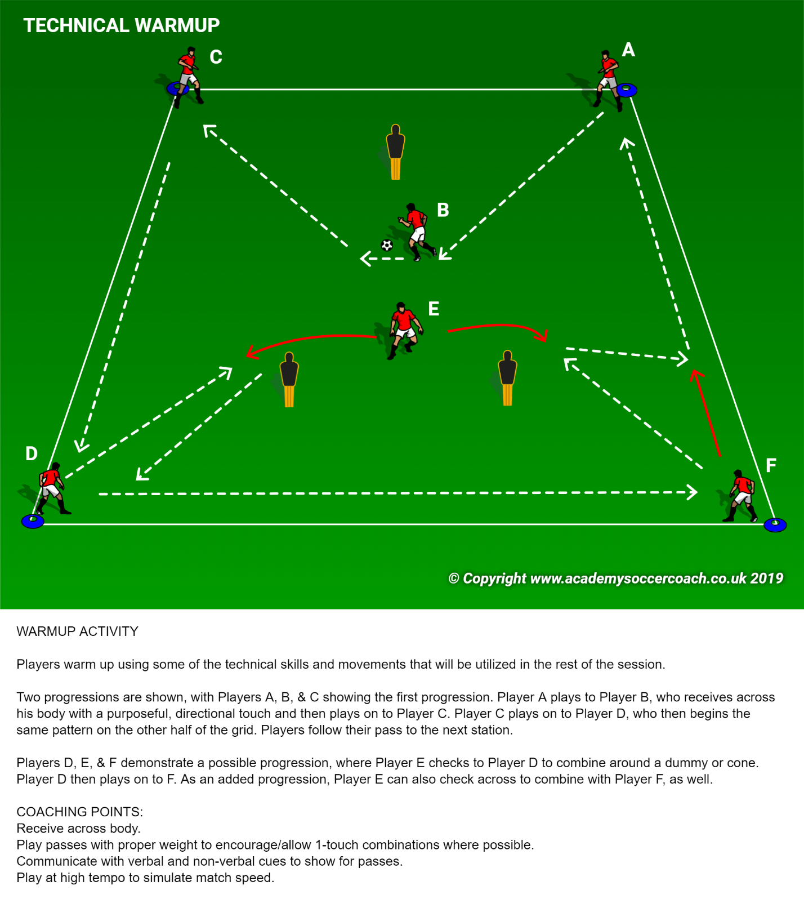

. 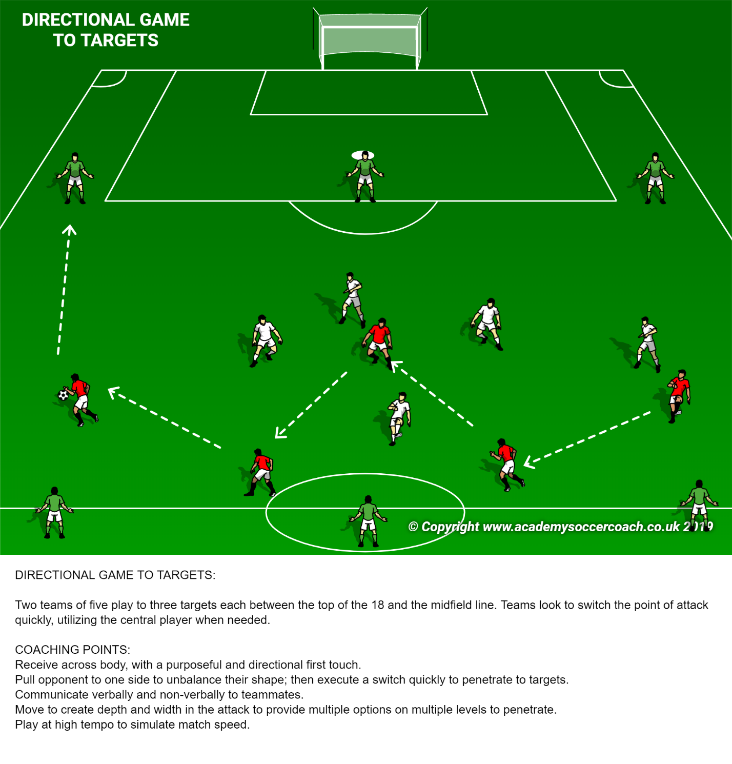

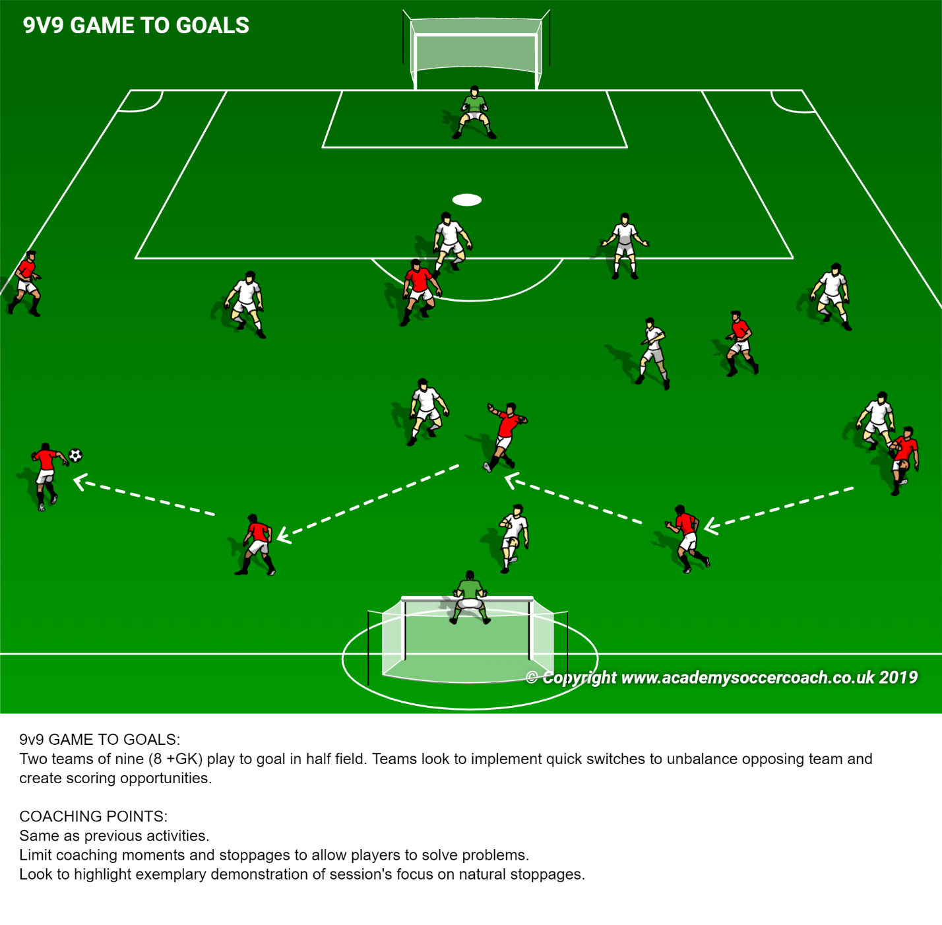  
**Bryan Daniel**

*VP of Education*

Head Coach, Indian Hill High School [Cincinnati]

Twitter: @MisterBDaniel

**From College Coaches –**

***Steve McCrath***

Head Men's Soccer Coach

Barry University

11300 NE 2nd Ave

Miami Shores, FL 33161

“When it comes to climbing stairs, there’s always a push that’s needed.  Some like to skip a step and power up and others need one step at a time.  The problem with that is example isn’t how one is moving faster and higher than another, but ‘why’?  What isn’t asked enough is what is in the hands of the one going step by step. That could be weighing the one down vs the other.

The next level mindset is missing for most High School level players.  They want to go two steps but carry the baggage of a one-step person.  They are headers, but listeners.  They see, but do not do.  Every high-level player at the Division II level has the same characteristics.

-High drive (not just a me focused drive)

-High standards of commitment to skill level (not to be confused with results of winning or looking good)

-Athletic ability / strength

-Joy to play on their own

There are other characteristics too such as thoughtfulness and leadership and others-centered approach, but the above items are consistent in all.

Most kids think they have a high drive, but when they show themselves in tryouts or later, if they’ve made the team, the truth is, they don’t have high drive.  They aren’t encouraging others to go out to train, play and try stuff away from training to get better. They stay safe. Their drive is to win and it ends up showing up as a lazy or externally motivated mindset only.  It is me-centered vs an others-centered drive.

The commitment to do so shows up this way.  You aren’t the best because you are the best, you actually want to improve.  So, you are coachable.  Example: best dribbler on the team, but you lack bite in areas that create in the attacking 1/3rd. Your dribble is a “get out of tight spaces but doesn’t really go anywhere” or it’s a “fast-paced dribbler, but can’t get out of tight spaces.”  A best player would come in and ask the coach, “where can I get better.”  When the coach tells them, they respond with, “I’ve noticed that too in my video assessments of games.”  The key is, then they go work on that and hopefully sooner vs. later, it shows in games at the right times.

Athletic ability is formed young. It can be improved in high school but it requires consistency and wisdom and a heart to see it through.  Strong but slow or fast but lacking flexibility / agility isn’t as helpful.  If you’re not fast, train to okay fast! If you aren’t strong, get a proper strength coach and blend it with football training. Be the top not only on your team, but in your league or state.

This goes back to high drive, but is different. It’s the joy to do all of this even on days that are tough. Like a great relationship, there WILL be days you feel that it’s frustrating, painful or maybe even plateauing. If you have a great relationship, you’ll see the joy - not happiness - in the tough things brought your way. You smile on the inside to do these things and because of that, you bring positive things back to the table of your own that other(s) can and will feed off. You have goals but you don’t sacrifice others.  You get stuff done without crushing those ahead of you to reach that target blindly.  You are a teammate and also one to take the brunt of pressure and yet, so moldeable that learning is a staple of your make up.

If this makes sense to you, then you are a learner.  If you don’t put this into practice, then you are merely a hearer and not a listener.  A seer and not a doer.”

305.899.3560 office

305.331.2152 or 786.496.0479 cell

Men’s Soccer Questionnaire<<https://secure.assistantcoach.net/colleges/questionnaire.asp?QID=227&oid=150&sid=5316&hsid=&school_name=&city=&state=&whichpage=>>

Tom Crabill, Head Men’s Coach, Springfield College, Springfield Massachusetts

[menssoccer@springfieldcollege.edu](mailto:menssoccer@springfieldcollege.edu)

*Working on teamwork and communication while training*

*penetrating passing and movement-off-the-ball*

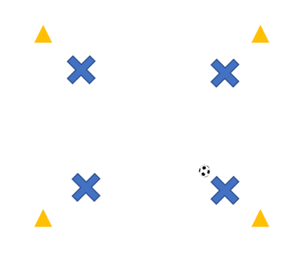1) We start with a passing warm-up in a 10-yard X 10-yard box with 4 players inside the box. With 1 ball, the players are to pass and move, saying the name of the person they are passing to, making eye contact, and using only 2 touches. In this simple task you can use simple coaching points:

* sprint into an open space after you pass the ball
* use either a stationary 1st touch to control the ball
* use a positive touch forward to control the ball
* pass and move
* stay on your toes to receive the ball

In this setting you can also practice passing with different sides of the foot, controlling with different sides of the foot, or a technical skill of your choice.

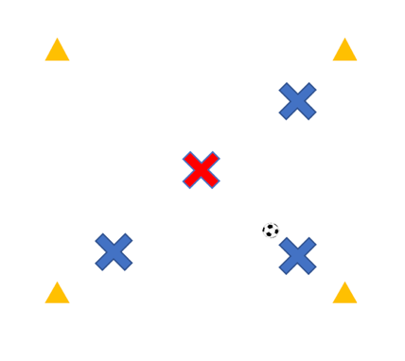2) In the same environment, assign 1 person to be the defender and play 3v1 in the 10 yard X 10 yard box, changing defenders when the ball goes outside the box, is intercepted by the defender, or however you see fit.

3) Penetrating passes: with two 10-yard X 10-yard boxes next to each other, sharing one sideline. Place 1 defender in each box, and force one group of 3 players to move with the ball through each box. The players must pass to a teammate across the line and cannot dribble. The defenders must stay in their box. If the ball goes out or is intercepted by a defender, the 3 players must go back to the start. In this environment there are many of the same coaching points as the first activity:

* sprint into an open space after you pass the ball
* use either a stationary 1st touch to control the ball
* use a positive touch forward to control the ball
* pass and move
* 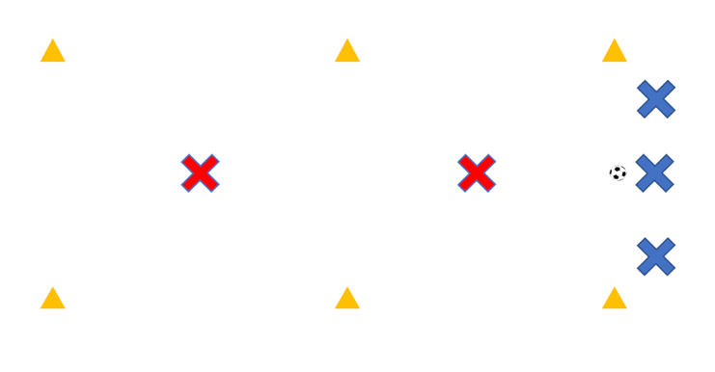stay on your toes to receive the ball

In this setting, while talking about the tactics of achieving the objectives, a coach can talk about teamwork, effective communication, and positive reactions to failure.

* While waiting in line for your turn to attack, talk with your teammates about runs you can make
* When someone makes a bad pass, give them positive encouragement, “we’ll get the next one, don’t worry”
* What angle of run can you take to receive the ball into the next zone?
* What angle of pass can you make to reach a teammate in the next zone?

4) This activity can then be added to an environment playing to goal in 6v4, 7v5, or however the coach chooses. The coach can start with an entry ball to one of the attacking players on the wing to begin the drill. When the attacking players get through one of the channels the remaining players join the game and the attacking team attempts to score on goal.

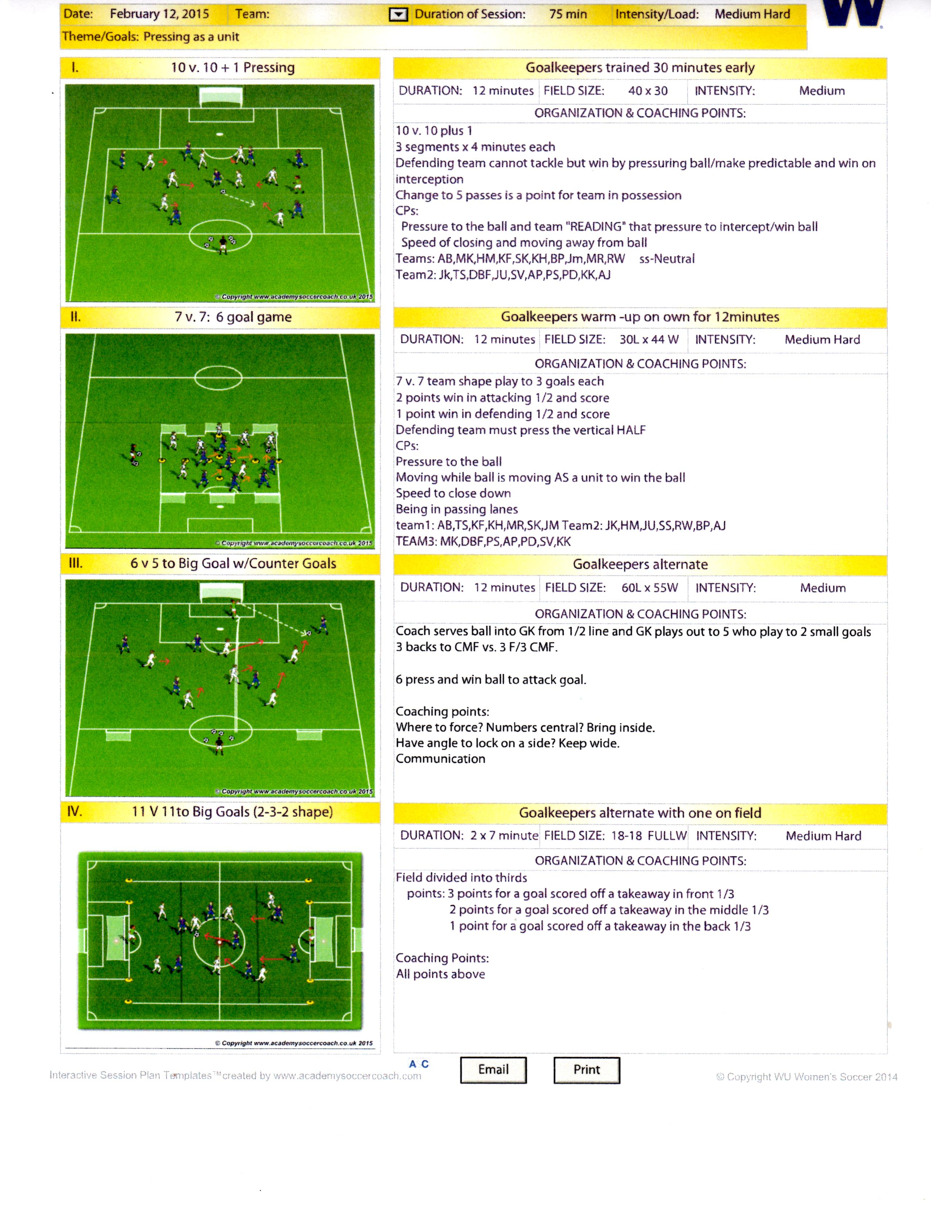

High School Coaches

Haroot Hakopian, Winston Churchill High School, Bethesda, MD; USC Board of Directors

"Here is the idea I have.  I coach at the high school and club level and have recognized an interesting pattern in the last few years...especially with the rise in popularity of ECNL.  At the club level, we focus on the individual development of a player in order to get her recognized by college coaches.  I think that has become the primary focus of club programs individual development for the possibility to play in college.  Again, I am not discussing scholarships, simply an opportunity to play at the collegiate level.  What this has created, to the dismay of MANY club and HS coaches alike, is a generation of players that are well versed in individual technique and individual tactics but lack the understanding to incorporate these skills in the game as a whole.  In essence, we are producing great players but not great teams. I have lots of anecdotal information that I can add which will reinforce this idea.

In my training sessions at the HS level, I focus A LOT on team tactics ESPECIALLY in moments of transition.  I firmly believe that the team that wins those moments will usually end up winning the game. If this is ok with you, I will send along a session (6v6 plus 3 for each team) that deals with moments of transition and team defending and attacking as the transitions occur.



 • Possession play inside the grid

• No restrictions to start EXCEPT outside players MAY not pass to each other

• 4 consecutive passes count as a goal

• When pass is made to a teammate outside the grid, player who initiated the pass and player who received the pass switch positions

• Players outside the grid should move with play to make better targets

**Coaching Points**

**Defending –**

Immediate high pressure on ball

Condense space

Make most difficult passes the best options (long/flighted passes, furthest player from ball)

**Attacking –**

Quick speed of play

Decision making (best option might be to dribble penetrate rather than pass, especially in transition)

**Progression/Restrictions**

-Touch Restrictions

-Combination Play when using outside players

-For high level teams, outside players have 1 or 2 touches, outside players may defend each other as ball is received

X1 and X2 Lean into the wall and lock it in place.

X3 step in front of wall to help stop it from running forward.

X is to serve a pass to the runner (XR OR XL) that X feels is in best position to finish relative to other defenders.

XR & XL make strong runs. They are also there to try to distract the vision of the GK. They start the play when they start to run. XR will shoot. XL will look for rebound. XR & XL need to practice their runs so as to avoid running into each other which is easy to do!

Rest protect against fast counter attack.

I would like to share a quote with the publication:

'If you want something that you have never had before, you will have to do things you have never done before"

Thanks,

Dino McIntyre

Walsh Jesuit HS

Steve Popp, Women’s Varsity Soccer – Head Coach, Beavercreek High School

Soccer Restart Training Session October 10, 2019

The restart, direct/indirect kicks, may be one of the best opportunities you get to score in a big game. A challenge with restarts is how to train for them and still keep a good tempo at your training session.

Our training sessions are fast-paced, competitive sessions. Restart training can slow them down. We incorporate team play and a competitive environment in our restart sessions to keep players focused and on point.

Our sessions not only address the attacking side of restarts, but we are also able to work on defending them at the same time. Here is one session we use to work on taking and defending direct/indirect restarts:

Session 1:

* Divide your players into 3 teams. We use our 18 players to get 3 teams of 6.
* Each team is assigned a number or a color to create your rotation.
* To start, team 1 is at a marker at the bottom of the center circle, team 2 is at the 18 and team 3 is behind the goal.
* A coach sets a ball outside the 18-yard box and on command, play begins.
* Team 1 goes to set up their free kick, team 2 sets the wall with direction from the keeper and uses any extra players to mark, team 3 is waiting behind the goal until the play is complete.
* After team 1 takes their shot, the coach sets another ball and team 2 now runs around the marker at the bottom of the center circle and becomes the attacking team, team 3 comes out from behind the goal to set the wall, team 1 jogs off and goes behind the goal.
* Rotate so each attacking group gets 10 restarts and keep score. This keeps it competitive and brings out the creativity in your players
* The coach can add as many parameters as you like, i.e. two or three on the ball, direct or indirect kick, etc.
* We encourage the team behind the goal to get together, discuss ideas and come up with ways to be creative with their restart opportunities.
* The constant rotation keeps players moving while at the same time gives everyone on your team experience in setting the walls with the direction of your keeper.

We spend a lot of time as coaches trying to come up with the perfect restart but many times, we have no idea how our opponent will set up to defend. Restarts need to be flexible. They should be flexible enough that your players have options based on what the defense is giving them.

Make it a point to incorporate restart training in your sessions. It will give your players the confidence and composure to read a situation in a game to run an effective set piece.

From the Director of Referees for the OHSAA

Don Muenz

**Fouls and Misconduct: The Economics**

Let’s take a look at fouls and misconduct, analyzing whether the foul and/or misconduct is “worth it.” We will compare costs with benefits, using as our barter currency, expected goals.

**Costs of a Foul Benefits of a Foul**

**The Restart**

Distance from goal Prevents dangerous

How much goal to shoot at opportunity for scoring.

Wall? Difficulty of offended

Time remaining team to score for remainder

IFK of match

DFK

PK

**The Rest of It**

Referee is more watchful of how

offending team plays.

Referee calls more fouls against.

Referee calls fewer fouls for

**Caution--Cost**

Offender must play more cautiously If foul is physical,

for remainder of match. intimidation factor.

Next caution becomes a red card.

Teammates must help offender, If against team’s target

at the expense of leaving own responsibilities. player, style and direction

Referee keeps an “eye” on offender. of offense may change.

The above may render offender’s If skilled opponent is

team more vulnerable to being scored injured, even if not out of

upon. match, intimidation factor

and loss of effectiveness.

Refs can be naturally

reluctant to disqualify.

**Costs of a Foul Benefits of a Foul**______

**Disqualification--Cost**

Harder for offending team to score Human instincts of

for remainder of match. referees may lead weaker

Harder for offending team to defend ref to “even up” the

for remainder of match. match.

More subs required because offending Prevention of obvious

team must play with more intensity in goal-scoring opportunity

order to make up for loss of the offender. Time remaining

Playing time lost via extra subs.

Two-match suspension for straight red

card offense.

We have a very rough framework with which to evaluate fouls and misconduct situations.

Let us make a few assumptions and see where analysis takes us.

Average number of goals scored per team is two, so teams will score an average of 0.25 goals per ten minutes of play at full strength.

Loss of a player numerically reduces team strength by 9% on offense and 9% on defense, or 18% altogether. Because it is unusual for a shorthanded team to score, the probability of its scoring has been reduced to 25% for the remainder of the match. The probability of the offended team’s scoring has been increased by 25%. Both of the foregoing reflect a shorthanded team’s tendency to pack into a defensive shell and restrict itself to counters.

This is the “Danger Zone” for free kicks.

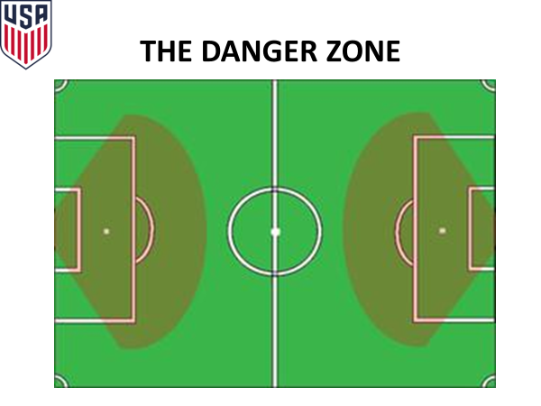

It extends for about 35 yards in an arc, from each goalpost. It is the area from which most goals are scored during dynamic play and set pieces. It is also the area in which walls are most effective.

With this rough framework in mind, let’s take a look at a situation and see how we come out.

**We have a non-DOGSO** (no denial of an obvious goal-scoring opportunity) situation. X-1, her team’s target player, has the ball at her feet, with her back to goal at the top of the penalty arc and is marked by Y-5, who is directly behind her. Y-5 is recovering from an ankle sprain and has only about 80% of her normal footspeed and quickness. She is worried that X will turn her and take an open shot from the top of the penalty area. Y-6 and Y-7 are a couple of steps away and closer to their defensive goal line than Y-5. Y-5 decides to give X-1 a “rough ride” from behind, to dislodge the ball and to take X-1 off of her game. Y-5 is willing to push the edge of fouling, because she fears X-1 will shake loose and take that shot. Y-5 finally pushes X-1 with sufficient force to take her off of the ball. The referee whistles for the foul, because the push went beyond reasonable force, though nonviolent, and illegally took X-1 off of the ball.

Y-5 is giving up a DFK from 22 yards out, in the center of the field, smackdab within the Danger Area. Her team may or may not be able to form an effective wall. That depends on whether Team Y decides to take a quick free. Y-5 has prevented the feared open shot, with no wall. Y-5, via the physicality of her play, may have sent that intimidatory message, “Stay out of my area or this is what you will get.” The intimidation may result in Team Y’s moving away from an effective to less-effective, attacking tactics. X-1 may have taken a knock that makes her physically and/or mentally less effective during the rest of the match.

If the foul had not been committed, X-1 stood a good chance of getting off a shot from near the top of the penalty area, with, perhaps, a 75% chance of scoring.

Based on a wall of five players, with nearly the maximum effective goal space to shoot at, the kick’s being direct and the distance to goal, was this an effective play by Y-5? Based on the foregoing factors, I would assign a 50% chance of a goal’s being scored from the kick, either directly or from a rebound.

This looks like a favorable tradeoff for the defenders, does it not? Other considerations may change the equation. If the referee treats this as a deliberate tactical foul and cautions Y-5, other defensive costs are in play: Y-5 will be more closely watched for the remainder of the match, she must play more cautiously while carrying a card, may have to be substituted for more frequently and for longer periods of time, and teammates may have to “cheat” on their own responsibilities in order to assist Y-5, resulting in their team being more vulnerable to attacks.

The offender must determine whether reducing the probability of a goal’s being scored from 75% to 50%, is worth all of the remaining costs. See Costs and Benefits Table, above, and try your hand at it, sitting in an armchair.

**Let’s look at another situation.** In the tenth minute, P-5 has an OGSO, inside of the penalty area and 16 yards from goal. R-15, in a nonviolent slide tackle from behind, takes P-5 down, when the ball is 3 feet in front of P-5. No advantage can be given.

The referee awards a penalty kick. The referee also disqualifies R-15 for serious foul play, as, due to the positions of the ball and P-5, there could have been no attempt to play the ball.

Benefits to Team R from the foul and misconduct: Team P is denied an 80% chance of scoring a goal.

Costs to Team R of the foul and misconduct:

A penalty kick, with an 80% chance of a goal’s being scored.

Playing shorthanded for 70 minutes

Expected to score 1.75 goals during this time, at full strength.

1.75 goals x 25% = 0.50 expected offensive goals, a loss of 1.25 goals.

Expected to concede 1.75 goals during this time, at full strength.

1.75 goals X 125% = 2.2 expected shorthanded goals, a loss of 0.5 goals

Total Benefits = 0.8 goals

Total Costs = 2.55 goals

The misconduct in this instance actually costs the offending team very dearly, i.e., a net of 1.75 goals. Quite a price to pay.

Additional cost factors for the offending team: (1) more subs required because offending team must play with more intensity in order to make up for loss of the offender; (2) playing time is lost via those extra subs; (3) a two-match suspension for straight red card offense.

It is not a simple task to try to evaluate each of these factors in deciding whether a foul or foul + misconduct makes sense in the economy of the match, especially where a player must make nearly-instantaneous decisions on-field.

Something to think about, while you’re making a tournament run.

From the Sports Psychologist

**Psychology of Coaching Soccer**

**By Dr. Colleen M. Hacker, FNAP, CMPC and USOC Sport Psychology and Mental Skills Registry, Professor: Department of Kinesiology, Pacific Lutheran University, Tacoma, WA.**

Know the Factors that May be Stressful for Youth Players

Coaches and parents can do a great service to youth players by helping each athlete develop self-confidence, a sense of personal worth and mastery, and a constructive attitude toward failure and adversity. Behavior that adults view as encouraging can often be perceived by athletes as stress producing and pressure-filled. Kids will freely choose to participate in activities that they view as meaningful, enjoyable and fun. The challenge for adults is to maximize the inherent joy of what Pele calls “the beautiful game of soccer” and minimize experiences that increase children’s anxiety and likelihood of burnout. Never forget that children are not “miniature adults”. The cognitive, emotional and physical characteristics while unique to each athlete, do follow known and predictable developmental pathways.

**Practical suggestions for coaches:**

1. Avoid a “win at all costs” attitude.

When kids are asked to name their top reasons for participating in sport (having fun, being with friends, learning new skills, being active), “winning” doesn’t even make it to the top 5! In fact, kids would much rather play on a losing team than sit the bench on a winning team. Furthermore, youth sport athletes cite “not having fun” as the number one reason for dropping out of sport.

1. Transform parental pressure into parental interest, support and encouragement.

Kids who enjoy sport want to play, want to practice and want to stay involved. They experience infinitely more “want to” moments in sport than “have to” experiences. Their interest and passion shows on their faces. Trust what you see.

1. Avoid over training, long, repetitive practices and excessive time and travel demands.

Rather than standing in lines, keep kids moving and active. Listening to long coaching explanations may be acceptable for an older athlete but you can achieve great success following the KISS Principle (Keep it short and simple).

1. Avoid using perfection as the standard for judging an athlete’s performance.

Look for opportunities to praise what we call “successive approximations” which simply means getting closer and closer to the desired goal throughout practice. Chasing perfection is demoralizing and frankly impossible. Be on the hunt for successful moment in each practice and “Catch them being good” rather than only coaching and interacting after errors.

5. Don’t associate a player’s worth or value as a person with their performance and ability on a soccer field. Coaches may not feel it but kids often perceive that winning or performing well means that parents, coaches and leaders “like” them more. Instead, praise effort, improvement, good sporting behavior and positive team interaction.

6. Make sure that your non-verbal behaviors are congruent with your words and that the coaching is consistent across situations (i.e. sulking after a loss even though the team played well or being happy following a poor performance by a winning team). Put the athlete’s well-being first. Remember, eyes are upon you at all times. They watch, they listen and they learn by actions and words. Model the behavior, language and attitudes you want to see in your players.

**Realize That Effective Feedback is the Breakfast of Champions**

The familiar coaching adage that “what you do speaks so loudly that no one can hear what you’re saying” is especially important to remember when dealing with young athletes. Players benefit most from coaches whose actions reflect both their implied and stated values. The ability to observe, analyze and communicate effectively are three of a coach’s most valuable assets. A word of caution, however, is that the beneficial effects of verbal instruction decreases in direct proportion to the amount given. Remember again to: Keep it short and simple. Take time to video yourself coaching, not only at practice but also in games. Observe yourself as others see you. Frequently, there is significant difference between how coaches think they are talking, acting and communicating and what athletes perceive.

**Practical suggestions for coaches:**

1. Give specific, performance-contingent feedback to athletes (“way to keep your head down and ankle locked”) rather than general comments lacking performance-related information (“good job”).

2. Be liberal with praise. Most athletes prefer coaches who shout praise and whisper criticism rather than vice versa. Try to achieve a 5:1 ratio of positive and authentic coaching points to every one negative point. It’s so easy to have an Assistant coach, manager or even one of the parents keep track of the ratio in both practice and games.

3. Tell athletes what actionable and specific improvements need to be made, why and most importantly, how to make those corrections successfully and consistently. If you can employ “show and tell” coaching the impact is even greater. Simply demonstrate as you coach rather than just talking without concurrent action.

4. Observe and provide meaningful feedback to every athlete at least once each training session and game. Read that sentence again. At the very least, make a commitment to say each athlete’s name on your team at each and every practice and game.

5. Combine verbal praise with consistent non-verbal forms of encouragement (i.e. a high five; a smile and a pat on the back). For many kids, the soccer field is their “happy place”. It may be the one time in their day when they feel confident, motivated and special.

6. Maintain your credibility as a coach by being accurate and sincere in your feedback and praise. Ignoring errors, giving excessive praise for mediocre performance or excessive praise for performance on simple tasks conveys to the athlete that either you don’t know what you’re talking about or else you have very low expectations of them as performers.

7. Correct performance errors in non-threatening and non-punitive ways. Finding problems is the role of a critic not a competent soccer coach. Good coaching requires the ability to not only recognize problems but also to solve them through effective, practical and successful solutions.

8. Reward effort as much as outcome. Repeated effort, especially in the face of failure and adversity, is one of the most important ingredients for future success.

9. Use the “feedback sandwich” when correcting youngsters. Specifically, find something the player honestly did well and praise it the bread). Next tell the athlete what they did incorrectly, what they need to do to improve and why (the meat or the tofu if you prefer!). Then, finish with another positive, authentic encouraging or motivational statement (the bread).

10. Foster an environment that allows for athletes to try new skills, approaches and strategies without the fear of reprimand and punishment. Mistakes are integral to sport improvement. Ridicule, sarcasm and fear are impediments to both immediate and long-term performance successes.

**Putting it All Together**

Athletes learn the game of soccer not only through the directed learning experiences that coaches provide in practice and game play but also through indirect means by observation and imitation. As a sport leader, you are a powerful and lasting role model for athletes by your thought, word and deed. Parents and coaches can serve as a player’s greatest ally or worst nightmare depending on the attitude, behavior and motivation adopted for sport involvement. Remember, that the game is for the kids. It is not for the ego or bragging rights of adults. Our role, as coaches, is to provide an opportunity for participation for all interested youngsters, access to appropriate and safe environments for instruction and competition, exposure to caring and competent leaders, holistic consideration of the child’s entire development (physical, cognitive, social and psychological) and an unwavering belief in the worth and ability of children to succeed at their own unique level of accomplishment. When coaches expect every athlete to succeed, it’s amazing how many of them really do.

Rather than measuring success in terms of numbers in the win/loss columns, perhaps the ultimate standard of our success as coaches should be judged by our ability to teach children to love and enjoy the game of soccer, feel more confident and self-assured in their abilities and knowledge of the game, to experience mutual respect from both teammates and coaches, and most importantly, to feel appreciation and pride in the opportunity they had to play a sport they love under your direction as their coach.

Perhaps the most appropriate summary can be found in the “Bill of Rights for Young Athletes” (NASPE, 1979) written by medical, physical education and sport experts in the hope of creating guidelines to maximize the beneficial effects of athletic participation for all.

**Bill of Rights for Young Athletes**

1. Right of the opportunity to participate in sport regardless of ability level

2. Right to participate at a level that is commensurate with each child’s developmental level

3. Right to have qualified leadership

4. Right to participate in safe healthy environments

5. Right to each child to share the leadership and decision-making of their sport participation

6. Right to play as a child, not as an adult

7. Right to proper preparation

8. Right to equal opportunity to strive for success

9. Right to be treated with dignity by all involved

10. Right to have fun through sport

From A Member: Questions of the Month

Gary,

Can a coach speed up a player’s visual recognition of the right choice to make?

Joe Dragon

Lock Ness HS

Editor: YES, and Kevin McGreskin, Irish FA, Wales FA, Scotland FA, and UEFA “A”, has the answer in his program and videos. It’s called Soccer Eye Q.

I will show you a couple of simple exercises from his video that will show you the basic steps toward speeding up visual recognition of the right choices that begin the program.

Session #1

1. 3 with 2 balls 1Xo 2X oX3

2X receives ball from 1Xl. Must look over shoulder BEFORE receiving the ball. Can take one or 2 touches and return to passer. Turn and repeat with X3. PRACTICE LOOKING OVER BOTH SHOULDERS.

2. Same set up but now 2X must call out the color (red or blue) of the cone X3 is holding overhead. Hold up the cone as the pass is played. Take a good look at path of pass before turning. Adjust your feet so you're open a little then look over shoulder for the color of the cone.

3. Same set up but add two cones (red or blue) about 5 yards apart. 2X calls out the color and moves the ball sideways around the correct color cone and returns to passer.

**Δ**

1Xo 2X oX3

**Δ**

Be using the inside foot to move the ball past the cone and the outside foot to return to passer.

4. Remove the cones: Same set up and process except that now 2X must look over their shoulder to see the color and touch the ground with the same side hand that was holding the cone.

5. The same as 4 only add the cones as in #3 to move the ball around and return to the passer.