The OSSCA Quarterly
August

2018

ATTRACTIONS

Message from the President

John Johnson

From the Executive Director of OSSCA

Gary Avedikian

From Jeff Tipping, former Director of Coaching for the NSCAA

From Ohio High School Coaches
Coach Bryan Daniel – Indian Hill; VP for OSSCA Education
Coach Zorro – Sword High School

From the Director of Referees for the OHSAA

Don Muenz, OHSAA Soccer DoD

From the Fitness and Nutrition Specialist

From the Sports Psychologist
Dr. Steve Graef, PhD
Counseling/Sport/Performance Psychologist for Ohio State University Athletics

From A Member: Questions of the Month

An Article on the Contributions of Immigrants to Our Soccer History
Tim Schum – Past President, NSCAA

Dick Bate – The Great Teacher

From the President
John Johnson
Coaches,
I hope your preseason has been going well. We open the season this weekend and I wish you all the best of luck. As the season is now upon us there are several things that have been passed on to me by the OHSAA.
- Reminder that all teams will wear dark colors for home games and solid white jerseys and socks for away games.
- The NFHS has declared it illegal to cut the bottom of your socks at the ankle. This has become popular but it is illegal and the players will be asked to change socks.
- Players cannot use any hair control device that has a knot in it and this includes the use of pre-wrap as a hair control device.
- It has been stressed again that a player is NOT offsides until the touch ball it is not when it is played.
- The transfer rule has changed, so if you have a transfer make sure you check with your AD to determine which rule they will follow this year. It all depends upon when the player transferred to the new school. They will have to sit out half the season but it does depend which half they sit out depending upon when they transfer.
- Players are still only permitted to 3 halves in one day regardless of how the games are spread out and cannot play more than 42 halves in a season.
- It has been mentioned at several OHSAA board meetings that teams are not to hold Senior Night during the tournament. Apparently there some teams that do this and this is not permitted.

Jerry Snodgrass is now the Executive Director of the OHSAA and will no longer handle soccer. He has turned soccer over to his assistant Lauren Prochaska. The OHSAA generally does not take phone calls from coaches or parents. If you have a question you should go through your AD. You can ask your district president or a board member of the OSSCA. As Jerry is getting accustom to his new role as Executive Director and Lauren is adjusting to her new role, I ask that you run questions through your AD or the OSSCA.

Please update your schedules on the OSSCA website, it is important that you enter your schedule and keep it updated. If you forget your password please contact me at johncjohnson1965@gmail.com. I have been appointed to the NFHS national rules committee. The committee meets in January to review potential rule changes. If you have an idea for a rule change you can send that to me so I can discuss it with the OHSAA and the OSSCA to determine if it will be properly written up and presented to the NFHS.
Good luck this season and if you need anything please contact me.
John Johnson
Wadsworth High School
OSSCA, President

From the Executive Director of OSSCA
Gary Avedikian

You may have noticed that the USC Soccer Journal has a series of comments about Dick Bate due to his recent passing. While most of the comments center on what a fine person and soccer intellect he was, they don’t actually speak to his teachings.

Therefore, I am turning over my section to share with you Dick Bate’s teachings.

A Great Soccer Mind: Dick Bate

The complete teaching session is attached at the end of this Quarterly.

Just a thought: When all things are equal, it’s the quality of the decisions players make that is most often the difference in the outcome.

Lecture from Jeff Tipping, Former Director of Coaching, NSCAA

Match Analysis or “Reading the Game”
Why do it?
- Improve team performance during the game.
- To evaluate performance of players during the game.
- Prepare for an up-coming opponent.
- Improve the quality of playing, coaching, and observing skills.

Reading a game and seeing a game are not the same.
- Reading the game: what are you evaluating and what is your staff evaluating?
- How do you respond to whatever you saw?
- What to say at ½ time is affected.
- What to say at the end of the game is affected.
- Evaluate accuracy of your match analysis or reading of the game.
- How will analysis affect what you do with the team in its future training?

Our viewing perspective is very different from the player’s…this can lead to confusion in analysis and coaching of the players. They see the game vertically and we as coaches see it horizontally. The ideal place to view a game so as to read the game is from above and behind your team. This is the vertical view that the players have.
If we have assistant coaches, how do we use them? Are they sitting alongside us or do they have assignments and are stationed in areas where they can read the game more accurately? We don’t want to be spectators nor should an assistant.
Coaching the Game:
- We are expected to be emotionally distant so we can be focused on “reading” the game for coaching purposes. Being emotionally involved makes us spectators.
- Keep our brains in gear – analysis skills must be in use.
- We need to understand all systems of play as to their strengths and weaknesses in order to guide our team prior to a game or during the game.
- Anticipation of issues and the prescription to cure it are essential to success.
- Coolness under pressure is where the coach makes the difference.

Match Logistics Matters:
- Be sure every player knows their position’s responsibilities.
- Be sure that each assistant knows their area of responsibility and duties.
- Be sure that the communication of information to the players is thought through carefully. They must understand the first time.
- Be sure you have a system of communication with players and coaches during the games.

How the MLS looks at “reading the game.”
- They are always looking at the shape of their team in attack and defense.
- Evaluate individual performances…each player.
- Analyze the transition issues – if the ball is lost at any point on the field, are they in a shape that would aid them in defending immediately. (Do we explain to the kids what to do to defend if we lose the ball at different points on the field? We should teach them to know how to make immediate transition to defense anywhere.)

We need to know:
- The structural strengths of different formations.
- The structural weaknesses of different formations. (If we teach these two ideas to the players they only need to figure out what their formation is and they will know how to attack it. Most teams will show you their formation at kick off. Might be smart to always let the other team kick off.)
- If you have played the team before, you should prepare your team to attack their weaknesses and defend against their strengths. (If their crossing is really good, push them inside so their wings don’t get to cross.)
- Understand and teach the players how to understand the game’s defining moments:
  - 1st 5 minutes of the game.
  - Last 5 minutes of the half.
  - 1st 5 minutes of the 2nd half.
  - Last 5 minutes of the 2nd half.
  - Player red carded.
  - Missed PK.
  - A goal scored for or against.
  - Ref’s decisions – good or bad.

It is important to make strong teams ordinary by taking away their strengths and when playing weak teams, must fight to remain focused on execution.
Which team wins depends on which is the best team on that day.
Key players need to step up and play their key roles; they can’t fade in and out of the game.

Making changes during a game based on what you’re “reading.” If you’re watching your team, who is watching their team? Someone needs to be watching them.
- The major question: how long do you go before making a change?
- Don’t make a change if:
  - Comfortable with the defensive performance.
  - Passing is going well.
  - You are penetrating the opponent well.
  - Your best players are playing a central role.
  - Your players are all doing their jobs reasonably well.
  - Your system and shape are good.
  - Match ups with their players are going well for you.
- Make a change if:
  - You see problems with your style of attack and defense vs. theirs.
  - You see personnel problems in performance or match ups.
  - Situational issues…your team isn’t handling something they do.
  - Your formation or system is wrong to control the opponent.
  - Be sure they are trained in what changes you will make if they have a player ejected and how to play shorthanded.

Post-Game Analysis:
- What did the game show you need to practice?
- How did the game impact your future starting lineup?
- With an away game, be sure that you are prepared for different conditions than you thought would be there, like weather conditions.
- Review what worked well and what didn’t work so well.

Relative to Coaches:
They seem to come in two types:
- General Coaches who make general comments about the situations the team encounters. They don’t make comments that are actually instructional statements to an individual.
- Functional Coaches who give exact corrections or instruction to a player or several players about what needs to be done to achieve what they train to do.

We need to work at being more functional coaches.
When you adopt a system of play for your team, all aspects of training needs to be focused directly at how that system works.
Teach roles by position and work to improve the individual in the specifics of their role in the portion of the practice session that impacts their position.
If we see a team as having 3 units, then we can train each unit to perform its role better and then teach them to interact well. But the first thing is to teach each unit to do its job well. Train in a field that is only 25 to 45 yards long because that is how long the field actually is at any point where the ball is.
The 4 Major Moments in a Match:
- The shape of your team when in possession.
- Momentary reaction at moment of loss of possession.
- Shape when defending.
- Momentary reaction at the moment of regaining possession.

We need to train each of the three units of the team as to where to be in each of the 4 moments above. Then coordinate them with each other.
It is essential to teach counter-attacking from the different portions of the field and from different situations, i.e. a turnover in their defending 1/3 or a stolen throw-in. Most of the successful teams are excellently disciplined counter-attackers. (corner-kicks are particularly susceptible to the counter-attack problem.) (How do we deal with unexpectedly regaining possession?)
Always train: “What if we lose it now? What do we do?
Most popular formation being played worldwide.
In this formation, the wing defenders are expected to become wide MFs. This will create 2 diamonds up front instead of just one in the middle. Look familiar?

X X
X
X X
X
X X X X
GK

From Ohio High School Coaches
Bryan Daniel, Indian Hill, VP for Education

Session Topic: Transition to Defense Session Length: 90 minutes Space Needed: ½ Field
Coach: Bryan Daniel (Indian Hill High School [Cincinnati]) Twitter: @MisterBDaniel

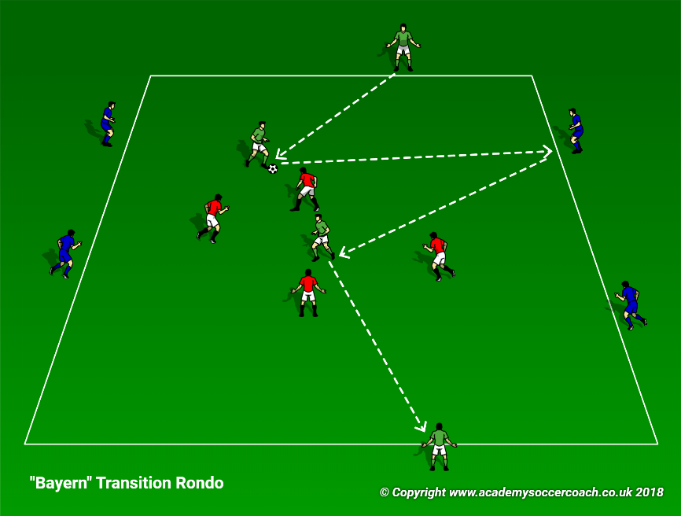
Bayern Transition Rondo
Fig. A
              - 15x20 grid (Fig. A)
              - (3) teams of four
              - (3) minute games, rotate teams
            - Green team plays 2v4 to end targets, using blue team as 1-touch bumpers to retain possession and work end-to-end.
              - 2-touch encouraged for central green players
              - Negative play to other target allowed
              - Blue cannot play to blue
            - Red team defends together to force turnover. Once they win ball, they play to either green target to trigger transition.
            - In transition moment, blue and red teams change roles (green stays).
Coaching Points:
- Defensive roles (pressure, cover, balance)
TIP: This activity can easily be used to focus on transition to attack by focusing on the green/blue roles and the transition from defensive role to wide player role.
- When defending (red):
  - Immediate pressure on ball
  - Good team shape (compact)
  - Deny ball into target
  - Squeeze the field (prevent easy switches)
- Immediate transition to defensive role (blue)
- Communication!
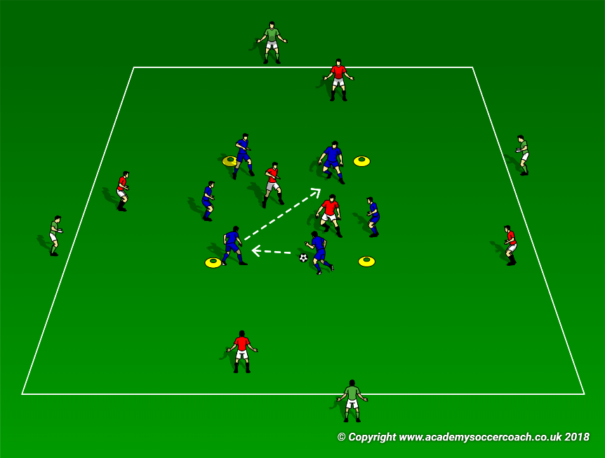
Breakout Transition Game (6v2 -> 6v6)
- 25x25 large grid; 10x10 grid in center (Fig. B)
- (3) teams of six (resting team [green] acts as targets)
- 3-minute games, rotate teams

- Blue team plays 6v2 inside small grid (2-touch max)
- Blue earns a point for every 10 passes inside small grid.
- When red wins ball, they play out to teammate in bigger space, triggering a transition to 6v6 game. Red earns a point for every 5 passes.
- If blue regains possession, they play to targets (green) to end the round.
- Reset each time back into 6v2 inside small grid. Play 3-minute games; rotate teams.
Fig. B
Coaching Points:
- Defensive roles (pressure, cover, balance)
TIP: Encourage outer red players and green targets to stay engaged by moving as they anticipate turnovers. No standing and watching! Be dynamic!
- Immediate transition to defensive role (blue)
  - Immediate pressure on ball
  - Good team shape (compact)
  - Squeeze the field (prevent easy switches)
  - Play quickly once ball is won to find target (green)
- Communication!
6v7 Transition To Defense/Press [in opponent’s third]
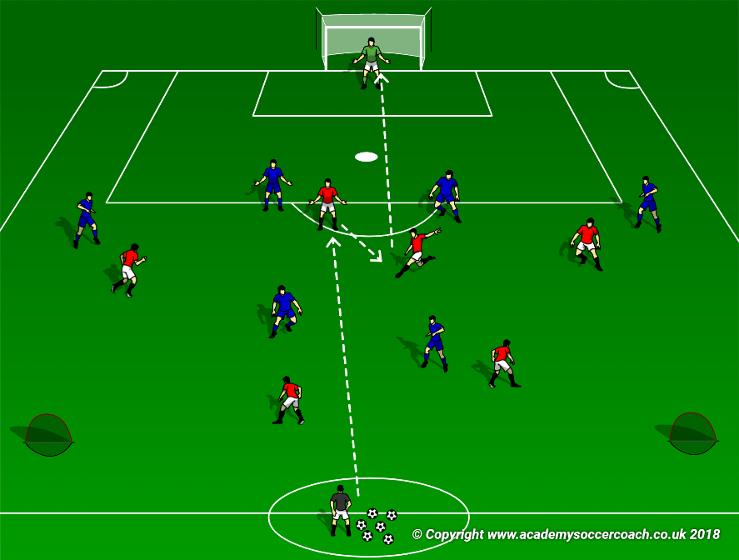
              - ½ field
              - (2) teams of 6 + 1 GK
            - Each ball begins with coach playing into red. Red combines against passive (50%, non-tackling) defenders to create a quick shot on goal (Fig. C)

            - If shot is saved, GK immediately puts ball back in play to blue team, who attacks the (2) wide counter goals. (If initial shot goes out of play, GK grabs ball from beside goal and puts into play to blue team). (Fig. D)

            - Red team defends together to force turnover. Once they win ball, they play quickly to goal

            - Play short games (5-8 minutes) at high intensity; rotate teams.
Fig. C
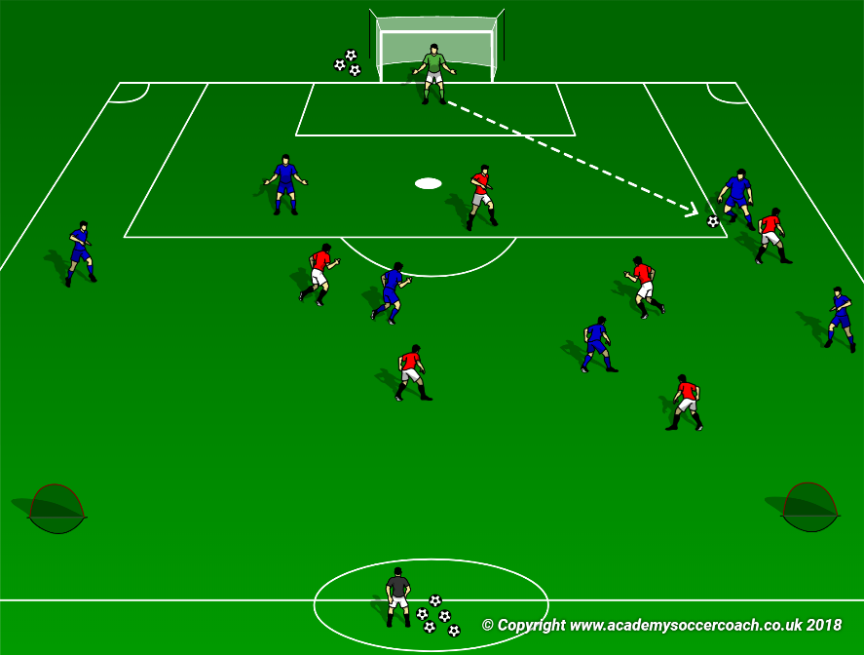
Coaching Points:
- Defensive roles (pressure, cover, balance)
- Immediate transition to defensive role (red)
  - Immediate pressure on ball
  - Good team shape (compact)
  - Squeeze the field (take away passing lanes & prevent easy switches)
  - Play quickly once ball is won to create an immediate scoring opportunity
- Communication!
Fig. D
TIP: Encourage outer red players and green targets to stay engaged by moving as they anticipate turnovers. No standing and watching! Be dynamic!
Coach Zorro – Sword High School - Favorite practice

A Game to Improve Possession and playing the way you face by Gary Divida
This practice may be most valuable with the reserve teams.
X X X
X X X
X X X
Version 1.
Initial game is a passing game in which you can’t pass to your color. You must pass to a different color.
Version 2.
Another modification is to make the central Mid Fielder a separate color and they can play to any color.
X X X
X X X
X X X
Should tell players that if they don’t hear, “turn” then they must play ball back to player’s color that sent them the ball. If they play the ball back, it should not go to the same player that gave it to them.
Version 3.
Still playing version 2, have players moving down the field at a trot.
Version 4.
Limit the number of touches, two touch, then one touch.
Version 5.
Add defenders into the mix while maintaining the provisions of Versions 3 and 4.
Attacking the Flat Back 4

- Playing the ball back to supporting players and sending the ball over the top. This is simple, but if a GK is trained to be very active in support – it’s stopped easily. The GK collects the through passes.
- Playing diagonal long balls to the wing MF’s can hurt the Flat Back 4.
- See below and diagram:
Break it like an off-sides trap. Play to Fs and they drop passes back to the central MF’s – the weak side WMF shoots through the gap created by the F pulling back toward the CMF’s. Weak side WMF makes diagonal run through and across the face of defenders into the gap and gets the ball – if the CMF’s overlap the two F’s, who are pulling back out of the attack, his can confuse the two Central defenders

Ball is solid arrows, runs are dotted arrows
- Low, bent crosses can hurt it if the balls are put behind the defenders for your Fs who are running diagonally across the face of the defense.
One answer for the defense to this attack is to stagger the defenders – this has its weaknesses too. When they’re staggered, an individual back can be double teamed by the two Fs and this may cause a 2nd defender to have to shift over to support the defender who is double teamed. This opens a large gap for MF to shoot through for a through pass.

- 1 and 2 touch play in and around the zone with diagonal runs by the Fs can cut inside the zone. The middle 1/3rd of the field is where this can open up fast breaks into the attacking 1/3rd.
- If Fs receive a ball from the MFs and dribble back toward the MFs, when the MFs overlap them into attack, they can pivot to face the attack and chip the defenders and put the two CMFs into the space behind their defenders. Done quickly, this breaks back 4.

Dotted arrows are runs; wiggle arrow is dribbling; solid arrows are ball movement.
- Training exercise for quick passing and to find the seams in Flat Back 4.
On a field 20 wide, set up 4 boxes 20X10 long. 4 players to a box. Alternating boxes are on the same team. Play 1 & 2 touch; the ball can’t stop; 4 passes is the maximum in each zone before you must find your teammates in the next zone.
Once the Red has passed to their teammates, then the other Red team is trying to pass back through the Blue team to the group that just sent them the ball. If the Blues intercept a pass, they then are trying to play to their teammates in the other box. After a 5 minute period, switch the boxes the players are in so that all players have a chance to play in the box where interceptions are possible.

From the Director of Referees for the OHSAA
Don Muenz

Long Attention Span Quiz…What You Think You Know vs. What You Know
Following are quiz questions to test your knowledge of current rules and the 2018-19 rules changes. Answer key at the end of the quiz. Enjoy.
1.) In lieu of anchoring, securing or counter-weighting a portable goal, the nets may be anchored, secured or counter-weighted with extra pegs and weights.
T
F
2.) It has been raining steadily for several days and has rained since sunup. The match is scheduled for a 7:15 p.m. kickoff. At 7:05 p.m., both teams and the referee team are present at the field and the home site administrator, without consulting them, declares the field unsafe for play and postpones the match, over the objections of the visiting team and the head referee.
Correct
Incorrect

3.) When the referee does not know who committed an act of misconduct on the field, the captain may be carded, as the captain is ultimately responsible for team conduct.
T
F
4.) B4 shows signs, symptoms or behaviors consistent with concussion. The head referee follows concussion protocol and, in the presence of an assistant referee, informs the Team B Head Coach that B4 may not play anymore that day, along with giving the coach all of the factual information which may help in B4’s treatment. At halftime, the head referee is approached by a person who produces a physician’s license card. This person states that, in her opinion, B4 was not concussed.
A. B4 may play in the second half, as a physician’s diagnosis overrides that of the head referee.
B. Under Ohio Law, the head referee’s observing signs, symptoms or behaviors consistent with concussion precludes B4’s return on the same day, regardless of a later, contrary physician’s diagnosis.
5.) A match is suspended due to lightning and play cannot be resumed.
A. It is an official game if at least one half has been played.
B. If the suspension occurred during the first half, the game may be completed from the point of suspension.
C. In A, the game may also be completed from the point of suspension by mutual consent of the schools.
D. All of the above.
E. A and B.
6.) A half is not over until the whistle sounds.
T.
F.
7.) In a state final, the score is 6-0 in favor of Team B. From the second half’s kickoff, the clock shall run continuously:
A. unless there is an injury or unusual delay deemed necessary by the officials.
B. the goal differential drops below six.
C. the head coaches agree that regular timing rules should apply, regardless of the score.
D. All of the above.
E. A and B.
8.) A goal may be scored directly from a drop ball.
T.
F.
9.) A goal can never be awarded unless the ball passes beyond the goal line, between the goalposts and under the bar without being deliberately handled by the attackers, except for a goalkeeper’s legal throw.
T.
F.
10.) A9 is disqualified for insulting, offensive or abusive language toward the head referee during the halftime interval. A9 was a player of record at the end of the first half.
A. Team A will play shorthanded in the second half.
B. Team A will not play shorthanded in the second half.
11.) After a foul is called against A8, he says to the referee, “You suck, Ref!” The referee:
A. Cautions A8 for dissent.
B. Disqualifies A8 for insulting, offensive or abusive language.
12.) Before S6 takes a corner kick, W7 punches S4 while both are standing near the penalty mark. The referee:
A. disqualifies W7 for Violent Conduct.
B. awards Team W a penalty kick.
C. Restarts with a corner kick.
D. A and C.
E. A and B.
13.) A5 is near the left post in her attacking goal area. A6 crosses the ball. B7, seeing that she cannot legally defend the cross, punches the ball away.
A. Penalty kick, caution B7 for unsporting conduct.
B. Penalty kick, disqualify B7 for serious foul play, denying an obvious goal-scoring opportunity.
14.) Serious foul play can only be committed while the ball is in play.
T.
F.
15.) Violent conduct can be committed by anyone on the roster or within the team area and not yet on the roster, against any other individual.
T.
F.
16.) An unidentified person within Team K’s team area uses insulting, offensive or abusive language toward the assistant referee on that side of the field. None of the referee team can identify the offender. The Team K Head Coach cannot identify the offender.
A. The referee gives Team A a team caution.
B. The Team A captain is disqualified.
C. The referee selects a Team A player at random and disqualifies him.
D. The Team A Head Coach is disqualified.
17.) If a player, coach or bench personnel enters the field without permission of the referee, but does not interfere:
A. Indirect free kick to the opponents from the touchline where they entered.
B. Indirect free kick to the opponents from the spot of the ball at the time that they entered the field illegally.
C. Indirect free kick to the opponents from the spot of the ball when the referee whistled for the illegal entry.
18.) At a penalty kick, where the kicking team infringes and the goalkeeper possesses the ball:
A. indirect free kick from the spot of the infringement.
B. Play continues.
19.) A sub who has reported in may be withdrawn by his coach by leaving the official area prior to being beckoned on by the referee.
T.
F.
20.) B3 is moving toward goal with an opportunity to score. Goalkeeper A1 comes out of the penalty area and handles the ball in an attempt to prevent the goal; however, a goal is scored. What action should the referee take?
A. Red card A1 for serious foul play and award the goal.
B. Red card A1 for serious foul play and award a direct free kick to Team B at the spot of the foul.
C. Yellow card A1 for unsporting conduct and award a direct free kick to Team B at the spot of the foul.
D. Caution A1 for unsporting conduct and award the goal.
21.) A2 is on the attack. She is fouled by B3 just outside of the penalty area. The referee gives advantage. A2 stumbles a bit, regains her balance and shoots over the top of the bar. The referee may then award a direct free kick at the spot of the original foul, because A2 did not score.
T.
F.
22.) A7 is on a breakaway, one on one with goalkeeper B1, near the penalty mark. As A7 attempts to run around B1, B6 runs in from behind A7 and tugs A7's jersey, pulling him off balance. As A7 falls, his right foot kicks the ball weakly toward the goal and it crosses into the goal at the far post.
A. The goal should not be counted, B6 should be shown the red card and disqualified and Team A should be awarded a penalty kick.
B. The goal should not be counted, B6 should be shown the yellow card and required to leave the field of play and Team A should be awarded a penalty kick.
C. The goal should count, B6 should be shown the red card and disqualified and the game should be restarted with a kickoff by Team B.
D. The goal should count, B6 should be shown the yellow card and required to leave the field of play and the game should be restarted with a kickoff by Team B.
23.) A11 has an obvious goal-scoring opportunity within the penalty area. In a desperation attempt to tackle the ball, B5 slides, making contact first with A11's ankle. A11 falls and there is no advantage to be played. B5's contact was not reckless or with unnecessary or disproportionate force and the referee judges it an attempt to play the ball. The referee awards a penalty kick to Team A.
A. B5 is cautioned for unsporting conduct.
B. B5 is disqualified for serious foul play in successfully denying an obvious goal-scoring opportunity.
24.) Prior to the match, the referee sees A4, who is wearing a head covering. The head wrap is not abrasive, hard or dangerous to any other player and is attached in such a way that it is highly unlikely to come off during play. A4 has a supporting OHSAA's statement at the field. The head wrap is legal.
T.
F.
25.) An identifiable supporter of the home team seated in the designated spectator area is screaming profanities at the nearest assistant referee in disagreement with a decision about offside made by the referee. The referee should:
A. Stop play and direct the spectator to leave the facility.
B. Stop play and request that the home school administration take appropriate action.
C. Stop play and inform the spectator that the assistant referee's decision was correct.
D. Allow play to continue and ignore the supporter's language.
26.) Attacker B9 runs towards the ball, which is rolling on the ground near the right goal post of her attacking goal. Defender A3 faces B9, with the ball behind her, and extends her arms wide to prevent B9 from running past her to get the ball. A3 does not make physical contact with B9. The ball rolls across the goal line to a goal kick.
A. A3 is guilty of pushing. The referee should award a penalty kick to Team B.
B. A3 is guilty of pushing. The referee should award a penalty kick to Team B and disqualify A3 for serious foul play.
C. A3 is guilty of obstruction. The referee should award an indirect free kick to Team B. If this was an obvious goal-scoring opportunity, A3 should be disqualified for serious foul play.
D. There is no offense, and a goal kick should be awarded.
27.) While A10 is dribbling toward goal, a substitute in the team area, B17, throws a water bottle at A5, striking him in the head. The referee immediately stops play, determines that A5 is able to continue to play and disqualifies B17 for violent conduct.
A. The game must be restarted with a direct free kick by Team A from the spot where A5 was struck.
B. The game must be restarted with an indirect free kick by Team A from the spot where A5 was struck.
C. The game must be restarted with a direct free kick by Team A from the location of the ball at the time A5 was struck.
D. The game must be restarted with an indirect free kick by Team A from the location of the ball at the time A5 was struck.
28.) In the first game of a junior varsity-varsity doubleheader, the referee determines that a junior varsity player, who also plays on the varsity, showed signs, symptoms or behaviors consistent with concussion. That player may not participate in a second game later that day, even with the written authorization from an appropriate health care professional.
T.
F.
29.) NFHS Rules do not prescribe the color of shorts to be worn by either the home team or the visitors.
T.
F.
30.) All permissible artificial limbs must be
A. Approved in writing by the OHSAA
B. The written approval must be at the match site
C. Padded with a minimum of 1/2 inch thick closed-cell, slow recovery foam padding
D. All of the above
ANSWER SHEET

1. F 11. B 21. F
2. Correct 12. D 22. D
3. F 13. A 23. A
4. B 14. T 24. T
5. E 15. T 25. B
6. F 16. D 26. C
7. E 17. B 27. A
8. T 18. B 28. T
9. T 19. T 29. T
10. B 20. D 30. D

From the Sports Psychologist for the OHSAA
Dr. Steve Graef, PhD
Counseling/Sport/Performance Psychologist for Ohio State University Athletics
Owner of Mindurance
Drsteve@mindurance.org
www.mindurance.org

instagram VERSE real life
February 17, 2018 by Steve Graef
There has been this movement on social media exhibiting the difference between what is posted and what is. It outs the reality that sometimes what we see on one’s feed isn’t exactly the full story. Instead, it’s a snap shot of something good, something perfect, something admirable. Meanwhile, the messy, the taboo, the forbidden, and the conflict is hidden well behind the phone or lap top. Far away from the eyes of those who might judge, avoid, disconnect, or escape. Hey don’t get me wrong. I love to see the good just as much as the rest, but what often happens is that we begin to integrate a false sense of reality into our schema of life. Constantly comparing ourselves to a level of consistent perfection that is impossible. Yes, I said it, IMPOSSIBLE. What emerges instead is jealousy, resentment, low confidence, anxiety, and depression. I can be just as guilty. Posting the picture of me up riding the wave on my personal account indicates that I easily hopped up on a surf board and road my little beach bum heart out. FALSE! IMPOSSIBLE! The reality, instead, consisted of a whole lot of falling. A whole lot of water up the nose and sand up my ass. A whole lot of frustration, struggle, conflict, and four-letter words. But, I didn’t post the fall picture originally because I wanted to prove that I got up. To who though?? Is anyone out there really losing sleep because I happened to struggle surfing in Mexico? Anyone? Doubt it. So who did I need to prove this to? Female followers that might find me a bit more attractive because of my increased athletic prowess? My athletic male friends who become impressed with my physical versatility? Does my family love me more because I tried surfing? Probably none of the above. Nope, instead I tried surfing for me and I wanted to share it with you. Not to prove to you. But to update you. To connect with those like-minded “yous”. Perhaps maybe even to inspire you to stretch your own boundaries and wide your own waves. But let’s not be fooled. That life that you see flowing through my feed is far from perfect. That is instagram. I actually live in real life…where the water is choppy as fuck and I have sand in my ass.

Editor: This might help to explain what is going on in some players’ minds when they are on Instagram. I don’t believe I have the right to edit out profanity from his published work.

From A Member: Question of the Month:

When I was a young coach and would go to the NSCAA convention, it always amazed me that the biggest names in coaching were willing to lecture and discuss their offenses and defenses. Coaches of all levels and abilities used to be willing to share and analyze ideas without hesitation.

Learning to coach and manage athletes went on in lecture halls and around a table in a bar.

I tell you this because I don’t understand why it is so hard to get our high school coaches to share information or even to be willing to ask a question.

I’m sure that the editor hasn’t gotten around to asking everyone in the OSSCA, but, why can’t he even get an answer when he does request a favorite training session or a question from a member?

Please volunteer and share your knowledge or ask questions.

Immigration Saved Soccer
By Tim Schum, Past President of NSCAA, Honor Award, Hall of Fame
With immigration currently a dominant issue, the passing of U.S. soccer legend Walter Bahr this week focused the role he and other transplants played in keeping the sport of soccer alive in this country.
With the world’s multitudes enjoying the 2018 World Cup, the concurrent death of Bahr at age 91 near State College, PA recalled perhaps the most historic event in our nation’s soccer history.
For Bahr was the last surviving member of the 1950 U.S. World Cup team that sprung a 1-0 defeat on England at Belo Horizonte, Brazil. Rated a 500-1 underdog, it was Bahr’s pass that teammate Haitian-born Joe Gaetiens headed in for the game’s only goal.
Unfortunately, today the positive contributions of our immigrant populations to our country’s development have been obscured by an administration seemingly oblivious to the historical facts of the issue. As one example there is no question that Walter Bahr and his like contributed to the maintenance of soccer as a sport in this country.
Not unlike many communities, Walter’s Philadelphia was home to a number of soccer-loving ethnic populations. Germans, Scots, Irish and others worked in the city’s then-textile industry by day and played competitive soccer weekends. Over time, with soccer as their magnet, social clubs emerge in the urban areas, allowing the cultural traditions of a given nationality to prosper.
This scenario was replicated throughout the Eastern seaboard and other of the nation’s cities. Eventually competitive regional leagues emerged with team names (the German-Americans, etc.) reflecting the teams’ legacies.
It was from these largely amateur leagues that the 1950 U.S. national team was selected. Coached by Scottish immigrant Bill Jeffrey, the team roster included players of Portuguese, Italian, Irish, German and Irish heritage. Whatever their background and against overwhelming odds, all pulled together to pull off the monumental upset.
In time many of that generation would follow Bahr example (he would coach at the secondary school and college level, eventually ending his Hall of Fame career as coach at Penn State) and contribute to the growth of the game in their locales.
While from 1954 forward the U.S. was absent from World Cup play until 1990, nevertheless the game was kept alive through play in our schools and colleges. Eventually through the impact of Title IX our U.S. women have become a dominant force at the international level while youth leagues and the establishment of Major League Soccer (MLS) have solidified the place of soccer in this country.
But without the under-appreciated devotion to the game as exemplified in the person of Walter Bahr it is doubtful that the sport would have survived.
In much the same manner it is hoped that that the contributions of our diverse immigrant populations to our culture are not minimized by spurious claims of an administration bent on rewriting history.
For to downplay those influences is to diminish the role that inclusion has played in our country’s successes and that has been the envy of the world.
Tim Schum coached men’s soccer at Binghamton University from 1963-1992.

The Future Coach
By Dick Bate

“Never look down before taking the first step.
Only he who keeps his eyes fixed on the far horizon will find the right road.”
Dag Hammerskjold – 1st Sec. General of the United Nations

Changes that may affect the role of the coach?
“I’m actually a lot softer now than when I first started in management. Society has changed. If you don’t change with it you’ll get left behind, so we all have to adapt. But you still have to be in charge of the group and there are times when you have to show you are in charge.” Tony Pulis (Stoke City Manager – December 2011)

Context
- Orthodoxy is being challenged.
- Mis of cultures, beliefs, values, religions & multi-cultural society etc.
- Generation differences between coaches & players 0 communicate differently.
- Beliefs and “authority” is being challenged and is less respected.
- Teaching – learning methods are evolving and plenty.
- Christianity, morality, ethics are being usurped by “anything goes”.
- Traditional beliefs are being dismissed as unimportant.
- Foreign players with differing beliefs, tendencies, values, backgrounds.
- Unprecedented media coverage of the game and the quest for scandal and transparency.
- Self-esteem, self-image, deemed to be critical but often lead to vanity and selfishness?
- Celebrity and hype are prevalent in the game.
- The critical and “WHY” generation.
- The W I I F M generation and the growth of non-judgementalism.
- Less stable backgrounds – family breakdowns.
- Digital and technological age.
- Difficulty in accepting criticism and more liable to contest and conflict.
- Game changes on and off the field.
- Visual thinkers?
- Need to be entertained?
- Shorter attention spans?
- Want to know why?
- Less “free play”?
- Adult early?
- “Many children starting school had led a very solitary, sedentary, screen-based existence.” – S. Palmer – Child Literacy expert.
Implications for the coach:
How to hold their attention.
Visual coaching – n, off the field.
Sustained concentration for success?
Repetition for efficiency?
Free- play practice?
Stimulate curiosity

Coaching Challenges
Performance Director
- Recovery scientist
- Exercise physiologist
- Nutrition
- Strength conditioning
- Performance psychologist
- Sports medicine
- Performance analyst
- Coaching
- Family/associates
- Performance lifestyle
- Bio-mechanist

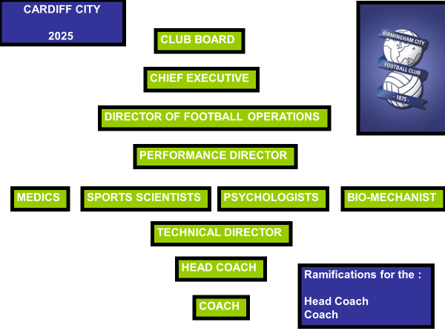

Structure’s Implications for the Head Coach:
- Only a “cog” in the machine.
- Reduced player numbers to work with/
- Told who can and cannot train.
- Confer with psychologist, sport science, medics, etc.
- Reduced ideal “team coaching.”
- Less training days for some players/
- Un-settled team structures.
Coaching Implications:
- Walk-throughs.
- Complete familiarity with “intensities” of training.
- iPad coaching/electronic coaching!
- Smaller and inconvenient numbers to work with.
- Demand on “adaptability” form coach & Players.
- Quick-thinking practice organization.
- Positional Specific Coaching.
- Technical coaching – well advanced.
- Younger players – time at task technically will be vital.
- Individual training programs.
- Talented individuals and so less team-work.
- Bigger squads to replace missing players.

SO

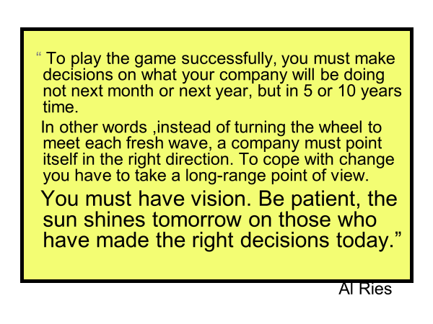

Future Coach Thoughts

What is needed:
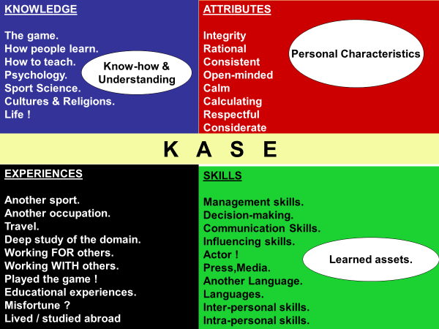

Coaching Intelligence

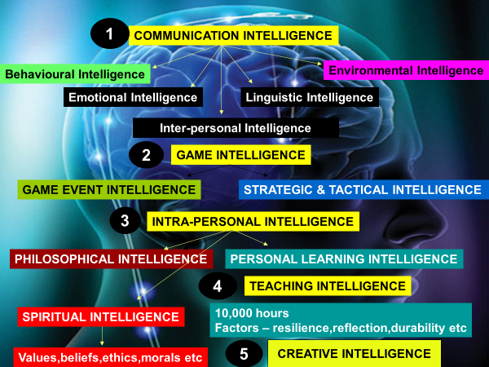

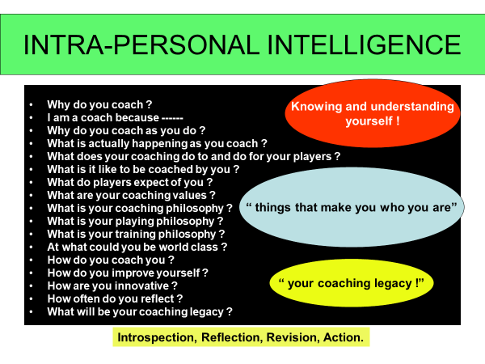

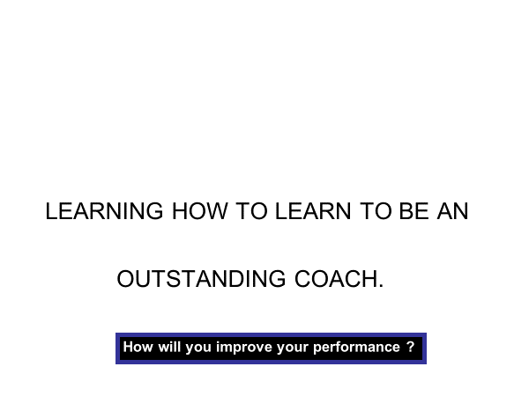
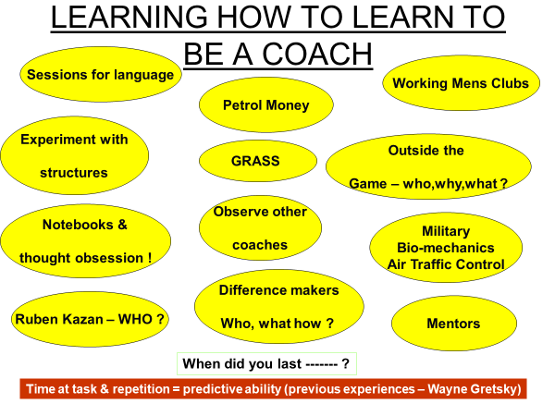
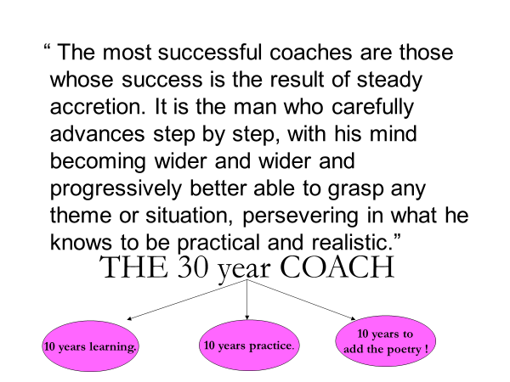

Football Playing Intelligence
Tactical & Technical Events
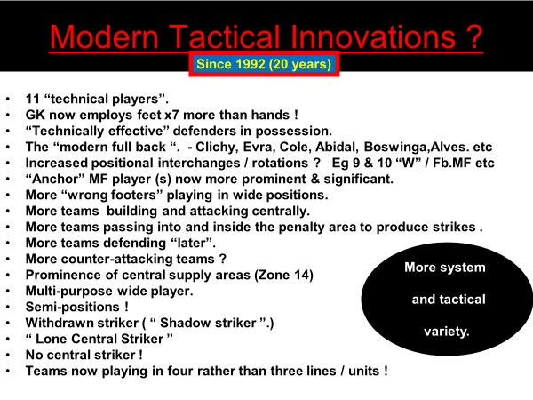
Football Intelligence
“the ability to observe and understand the unfolding game events and to reason and prioritize their importance in performance.”

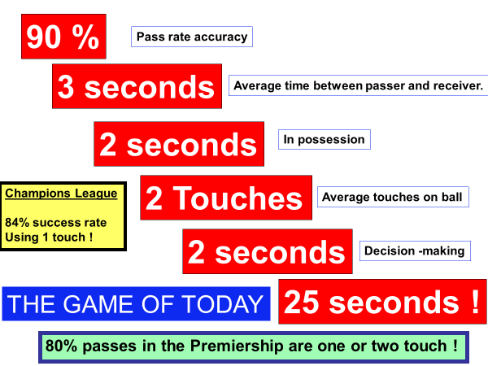

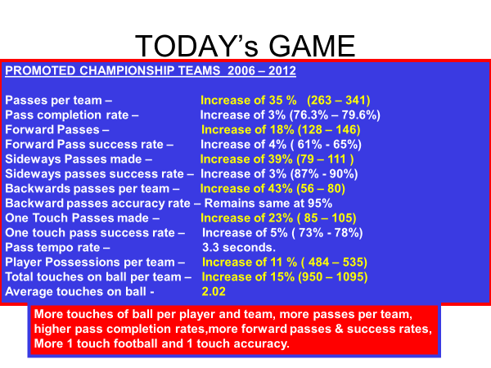

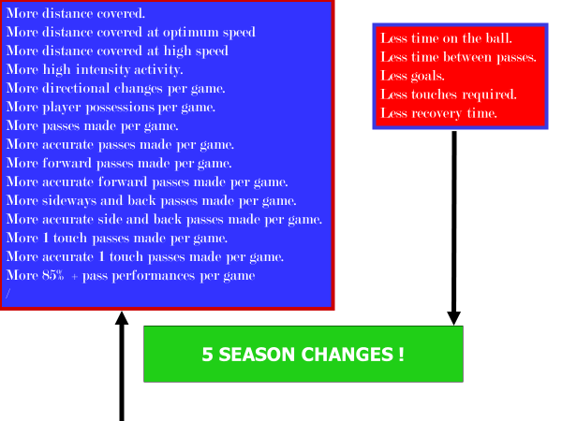
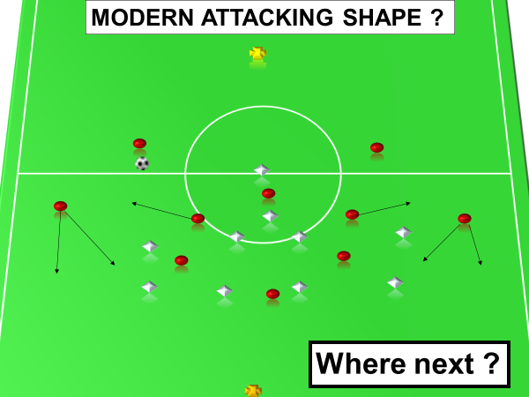

Tactical Intelligence
“where to go, when, how and why?
What to do and how?”
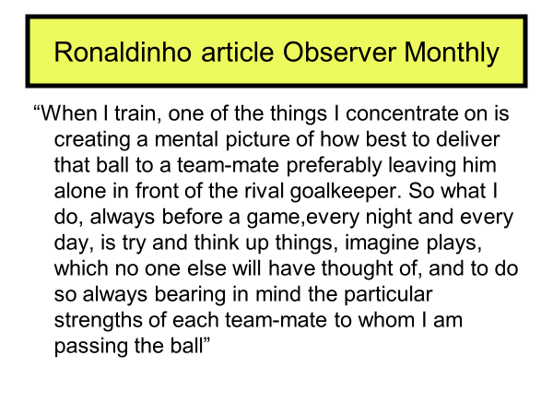
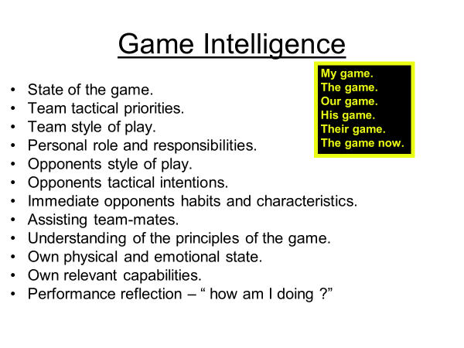

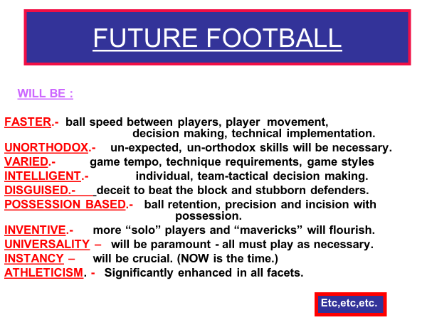
Teaching Intelligence

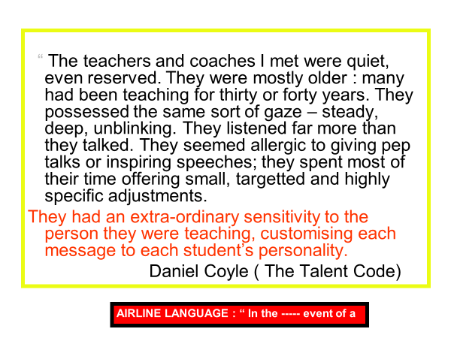

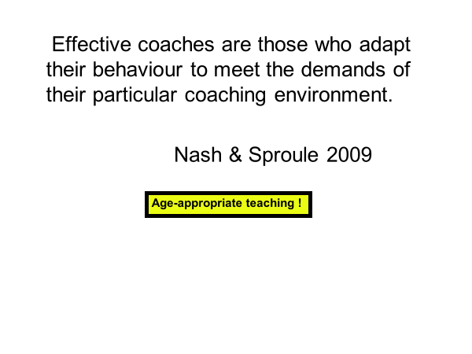

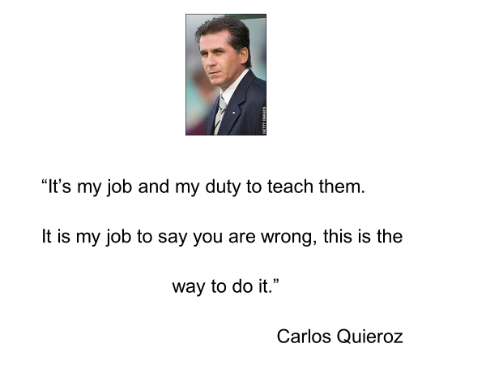
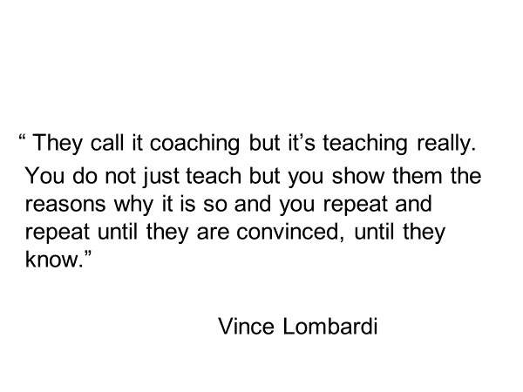

Teaching Intelligence

What?

How?
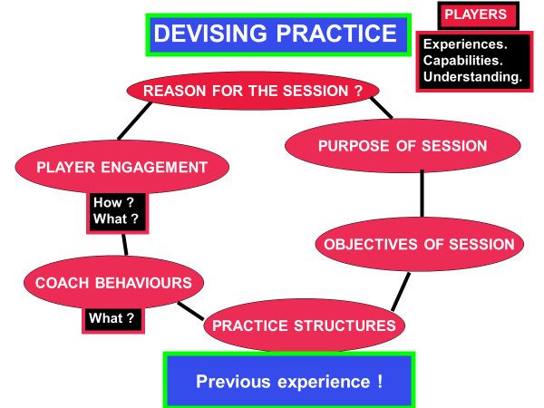
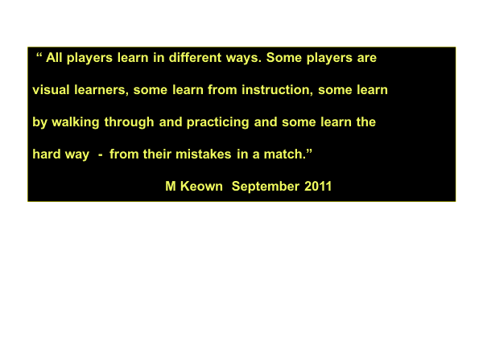

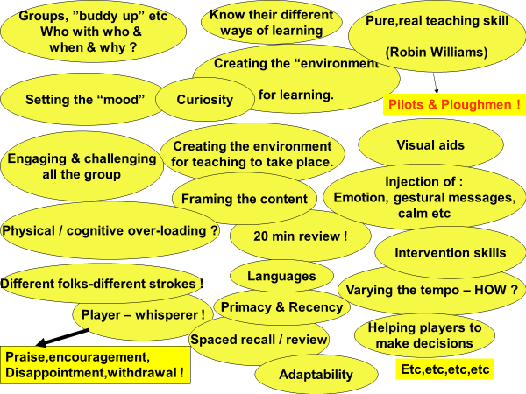

Emotional Intelligence
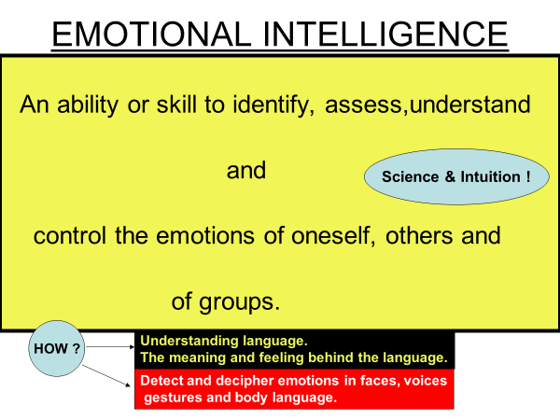

“The Modern Coach must strike a balance between strength and sensitivity.”
P. Barclay
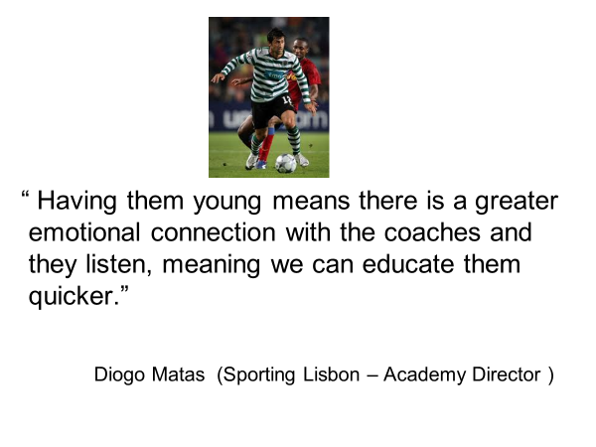
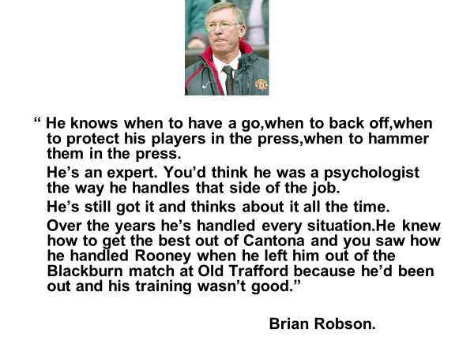

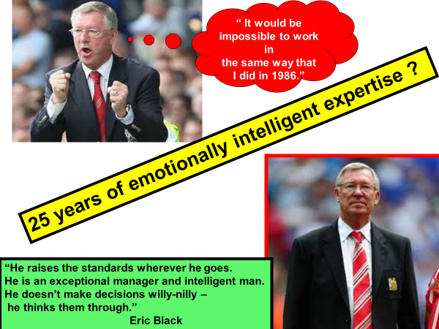

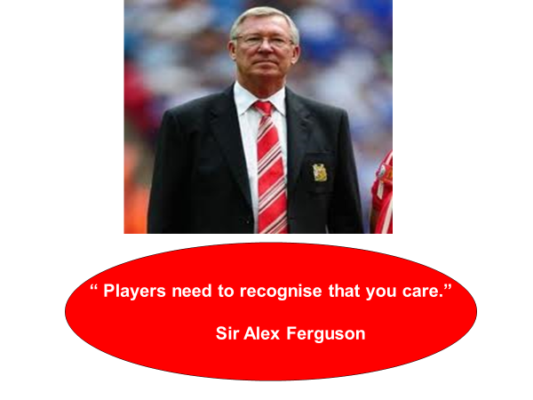

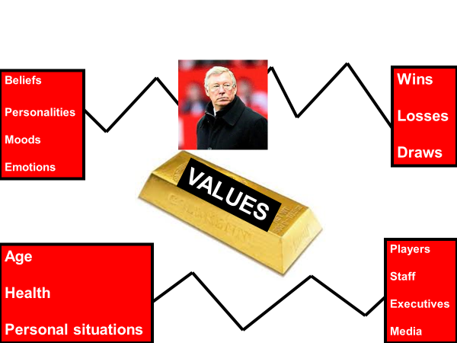

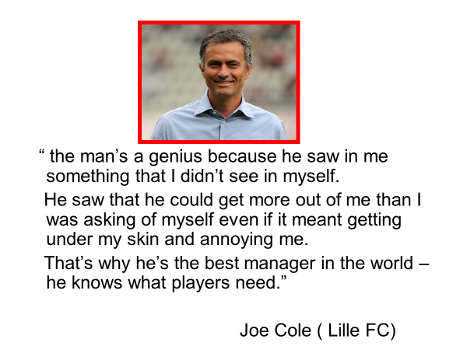

Inter-personal Intelligence
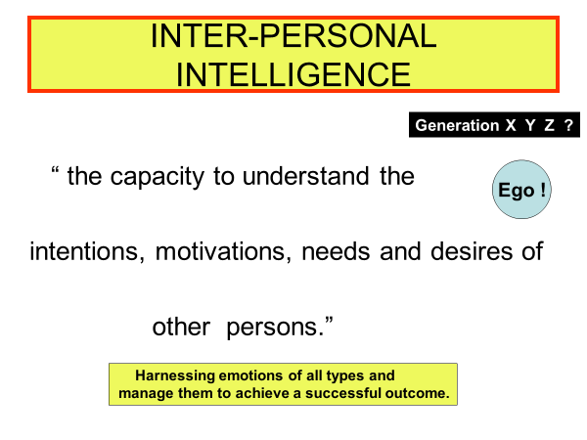

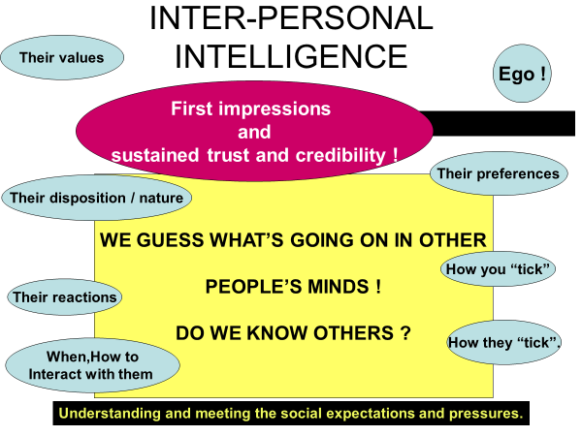

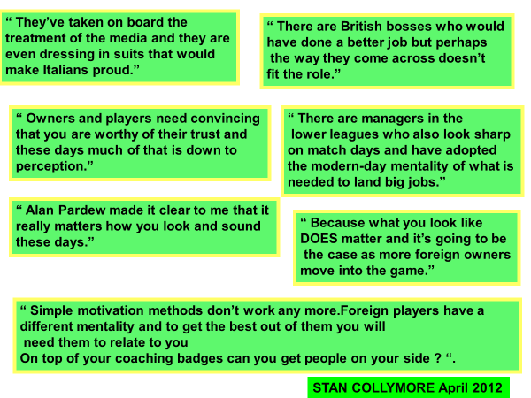
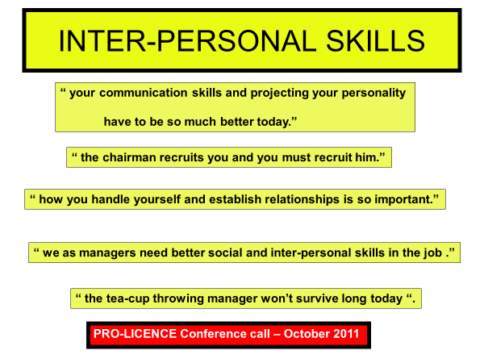

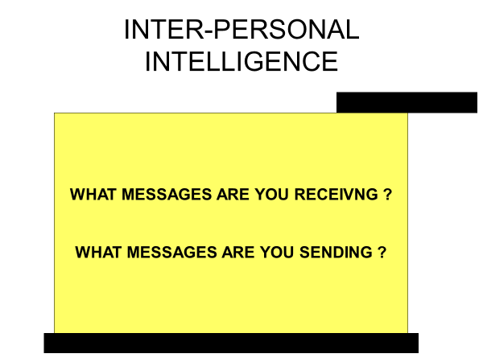

Communication Intelligence
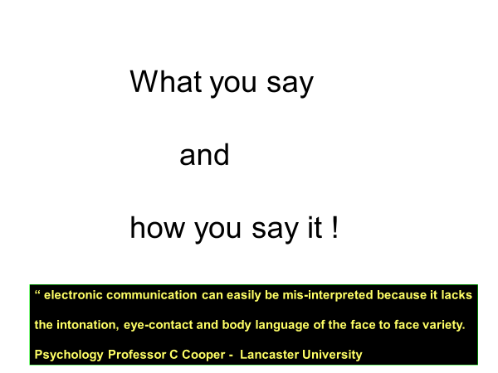

Implications for the Coach
“Different players demand different approaches. You can employ four different approaches in one team talk.”
Tony Adams (Portsmouth FC)

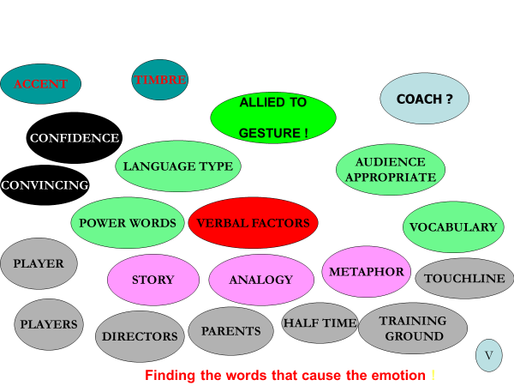
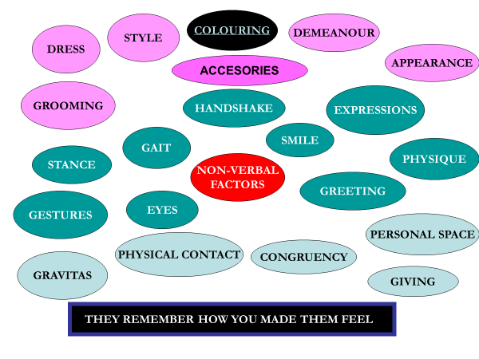
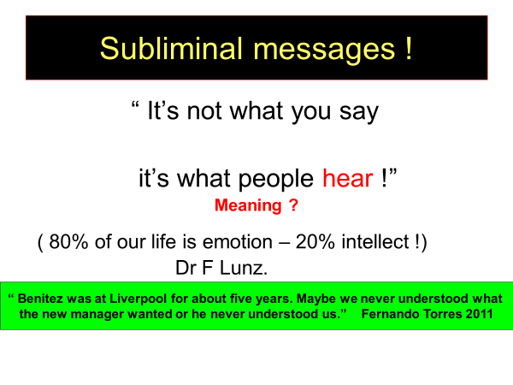
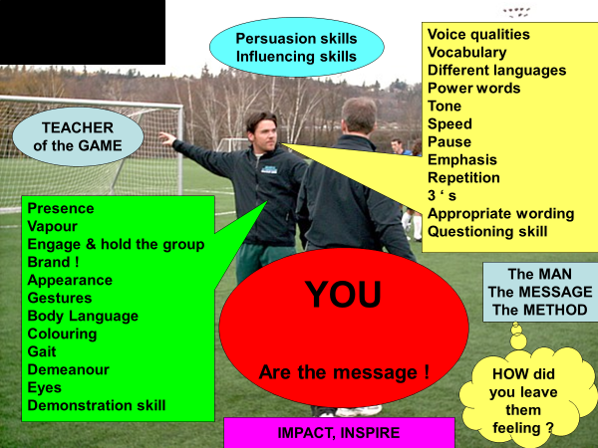

The End

